 | 7.1.1 Editors - 3D Viewport - Header tools and Options
Table of content
Detailed Table of content 1
Introduction 16
Mode Drop-down Box 16
Mesh Object Sub Modes 17
Grease Pencil Sub Modes 20
Geometry Node Group Tools 24
Object settings 25
Selectability & Visibility 31
Viewport Gizmo 32
Mesh Object - Sculpt mode 34
Mesh Object - Vertex Paint mode 38
Mesh Object - Weight Paint mode 40
Mesh Object - Texture Paint mode 42
Curve Object - Edit Mode 47
Viewport Overlays - all modes 47
Viewport Overlays - Mesh Object - Edit Mode 52
Viewport Overlays - Mesh Object - Sculpt Mode 56
Viewport Overlays - Mesh Object - Vertex Paint Mode 56
Viewport Overlays - Mesh Object - Weight Paint Mode 57
Viewport Overlays - Mesh Object - Texture Paint Mode 58
Viewport Overlays - Hair Object - Sculpt Mode 58
Viewport Overlays - Armature in Pose Mode 58
Viewport Overlays - Grease Pencil 58
Viewport Shading 64
Align View Buttons 81
Grease Pencil - all modes - Layer Panel 81
Grease Pencil - Options Panel 84
Grease Pencil - Sculpt mode - Auto-masking Panel 88

Detailed Table of content

Detailed table of content
Detailed Table of content 1
Introduction 16
Mode Drop-down Box 16
Object Mode 16
Edit Mode 16
Sculpt Mode 16
Vertex Paint 16
Weight Paint 17
Texture Paint 17
Edit Strokes 17
Particle Edit 17
Draw 17
Mesh Object Sub Modes 17
Edit Mode - Mesh Select Modes 17
Vertex Paint - Mask and Vertex Selection 18
Paint Mask 18
Vertex Selection 18
Weight Paint - Mask and Vertex Selection 19
Paint Mask 19
Vertex Selection 19
Texture Paint - Mask Selection 19
Paint Mask 19
Particle Edit - Select Modes 20
Mesh Object with a particle system. You can just have one method active at a time. 20
Path 20
Point 20
Tip 20
Grease Pencil Sub Modes 20
Edit Mode 20
Select Modes 20
Select Only Points 20
Select all Stroke Points 21
Select all Stroke Points between other strokes 21
Multi-frame 21
Use Falloff 21
Sculpt Mode 21
Selection Mask Points 21
Selection Mask Strokes 21
Selection Mask other strokes 21
Multi-frame 21
Use Falloff 21
View 22
Draw Mode 22
Origin 22
View 22
Multi-frame 22
Use Additive Drawing 22
Automerge 22
Add Weight Data for new strokes 22
Draw Strokes on Back 23
Weight Paint Mode 23
Multi frame 23
Use Falloff 23
Vertex Paint Mode 23
Select Modes 23
Select Only Points 23
Select all Stroke Points 23
Select all Stroke Points between other strokes 23
Multi frame 23
Use Falloff 23
Geometry Node Group Tools 24
Marked Assets 24
Unmarked Assets 24
Marked Assets with assigned Asset Browser Category 24
Object settings 25
Transform Orientations 25
View 25
Gimbal 25
Normal 25
Local 25
Global 25
Cursor 25
Parent 25
Create Orientation 26
Last Operator Create Orientation 26
Name 26
Use View 26
Use after creation 26
Overwrite Previous 26
Transform Pivot Point 26
Bounding Box Center 26
3D Cursor 26
Individual Origins 26
Median Point 26
Active Element 26
Snapping 27
Multiple Snap Targets 27
Snap Target 27
Closest 27
Center 27
Median 27
Active 28
Snap to 28
Increment 28
Grid 28
Vertex 28
Edge 28
Face 28
Volume 28
Edge Center 28
Edge Perpendicular 28
Snap Target for Individual Elements 28
Face Project 28
Face Nearest 28
Snap Peel Object 29
Snap to Same Target 29
Absolute Increment Snap 29
Align Rotation to Target 29
Back face Culling 29
Target Selection 29
Exclude Non-Selectable 29
Affect 29
Move 29
Rotate 29
Scale 29
Rotation Increment 29
Rotation Increment Slider 30
Precision Rotation Increment Slider 30
Proportional Editing 30
Settings 30
Proportional Size 30
Last Operator Proportional Editing 30
Proportional Editing 30
Proportional Falloff 30
Proportional Size 31
Connected 31
Projected(2D) 31
Selectability & Visibility 31
Viewport Gizmo 31
Show Gizmo 31
Gizmo Options 31
Viewport Gizmos 32
Navigate 32
Active Tools 32
Active Modifier 32
Active Object 32
Object Gizmos 32
Transformation Orientation 32
Move 32
Rotate 32
Scale 32
Empty 33
Image 33
Force Field 33
Light 33
Size 33
Look At 33
Camera 33
Lens 33
Focus Distance 33
Mesh Object - Sculpt mode 34
Color attributes panel 34
Global Auto Masking 34
Topology 34
Face Sets 34
Mesh Boundary 34
Face Sets Boundary 34
Steps 34
Cavity 35
Cavity (Inverted) 35
Create Mask 35
Factor 35
Blur 35
Custom Curve 35
Selecting Points 35
Adding Points 35
Navigation elements 35
Zoom in and out 36
Clipping Options 36
Use Clipping 36
Min and Max X Y 36
Tools 36
Reset View 36
Extend horizontal 36
Extend extrapolated 36
Reset Curve 36
Handle Types 36
X Y Position 36
Delete Points 36
View Normal 37
Occlusion 37
Limit 37
Falloff 37
Area Normal 37
Limit 37
Falloff 37
Mesh Object - Vertex Paint mode 37
Color Attributes panel 37
Active Color Index 37
Color index name 37
Active Render 38
Drag Handler 38
Search Field 38
Invert 38
Sort by Name 38
Add + 38
Add Color Attribute Popup 38
Name 38
Domain 38
Data Type 38
Color 38
Ok 38
Remove - 38
Adjust last operator Add Color Attribute 39
Specials menu 39
Duplicate Color Attribute 39
Convert Color Attribute 39
Mesh Object - Weight Paint mode 39
Vertex Groups 39
Active Vertex Group list 39
Group name 39
Lock 39
Drag Handler 39
Search Field 39
Invert 40
Sort by Name 40
Add + 40
Remove - 40
Specials menu 40
Sort by Name 40
Sort by Bone Hierarchy 40
Duplicate Vertex Group 40
Copy Vertex Group to Selected 40
Mirror Vertex Group 40
Mirror Vertex Group (Topology) 40
Remove from All Groups 41
Clear Active Group 41
Delete All Unlocked Groups 41
Delete All Groups 41
Lock All 41
Unlock All 41
Lock Invert All 41
Move Vertex Group Up / Down 41
Mesh Object - Texture Paint mode 41
Texture Slots 41
Mode 42
Add Texture Paint Slot 42
Paint Slot with mode Material 42
Material Paint Slot 42
Add Texture Paint Slot 42
Paint Slot with Mode Single Image 43
Image List 43
New/Open 43
Edit Box 43
Fake User 43
New Image 43
Open Image 43
Unlink Data Block 43
UV Map 43
Interpolation 43
Save all Images 43
Stencil Mask 44
Activate Stencil map 44
Stencil Image 44
Texture browser 44
Edit Box 44
UV Layer 44
Display Color 44
Invert the stencil color 44
Cavity Mask 44
Activate Cavity mask 45
Navigation elements 45
Zoom in and out 45
Zoom in and out 45
Tools 45
Reset View 45
Reset Curve 45
Use Clipping 45
Vector Handle 45
Auto Handle 45
Auto Clamped Handle 45
X / Y 45
Delete Points 45
Curve Object - Edit Mode 46
Set Handle Type 46
Auto 46
Vector 46
Align 46
Free 46
Toggle Free/Aligned 46
Last Operator Set Handle Type 46
Type 46
Viewport Overlays - all modes 46
Guides 47
Grid 47
Floor 47
Axes 47
Scale 47
Subdivisions 47
Options 47
Text Info 47
Annotations 47
Statistics 48
3D Cursor 48
Camera Guides 48
Objects 48
Extras 48
Light Colors 48
Relationship Lines 48
Outline Selected 48
Bones 48
Motion Paths 49
Origins 49
Origins(All) 49
Geometry 49
Wire frame 49
Wireframe Threshold 49
Opacity 49
Face Orientation 49
Fade inactive Geometry 49
Viewer Node 50
Color Overlay 50
Opacity 50
Text Overlay 50
Motion Tracking 50
Camera Path 50
Marker Names 50
Track display type 50
Track size 51
Viewport Overlays - Mesh Object - Edit Mode 51
Mesh Edit Mode Overlays 51
Bevel 51
Crease 51
Seam 51
Sharp 51
Faces 51
Center 51
Indices 51
Shading 51
Retopology 52
Vertex Groups Weights 52
Zero Weights 52
None 52
Active 52
All 52
Mesh Analysis 52
Type 52
Overhang 52
Minimum/Maximum 52
Axis 52
Thickness 53
Minimum/Maximum 53
Samples 53
Intersections 53
Distortion 53
Minimum/Maximum 53
Sharp Edges 53
Minimum/Maximum 53
Measurement 54
Edge Length 54
Edge Angle 54
Face Area 54
Face Angle 54
Normals 54
Display vertex normals 54
Display split normals 54
Display normals 54
Constant Screen Size Normals 54
Size 55
Freestyle 55
Edge Marks 55
Face Marks 55
Viewport Overlays - Mesh Object - Sculpt Mode 55
Show Mask 55
Show Face Sets 55
Viewport Overlays - Mesh Object - Vertex Paint Mode 55
Opacity 55
Show Wire 55
Viewport Overlays - Mesh Object - Weight Paint Mode 55
Opacity 55
Zero Weights 56
None 56
Active 56
All 56
Show Weight Contours 56
Show Wire 56
Show Bone X Ray 56
Viewport Overlays - Mesh Object - Texture Paint Mode 56
Stencil Opacity 56
Viewport Overlays - Hair Object - Sculpt Mode 56
Selection Opacity 57
Curves Cage 57
Cage Opacity 57
Viewport Overlays - Armature in Pose Mode 57
Show Bone X Ray 57
Bone Wireframe Opacity 57
Viewport Overlays - Grease Pencil 57
In Object Mode 57
Onion Skin 57
Canvas 57
Canvas X Ray 57
Fade Layers 58
Fade Objects 58
Fade Grease Pencil Objects 58
In Edit Mode 58
Onion Skin 58
Canvas 58
Canvas X Ray 58
Fade Layers 58
Fade Objects 59
Fade Grease Pencil Objects 59
Edit Lines 59
Stroke Direction 59
Only in multi frame 59
Material Name 59
Vertex Opacity 59
Handles 59
None 59
Selected 59
All 59
In Sculpt and Weight paint Mode 60
Onion Skin 60
Canvas 60
Canvas X Ray 60
Fade Layers 60
Fade Objects 60
Fade Grease Pencil Objects 60
Edit Lines 60
Only in multi frame 60
Vertex Opacity 60
In Draw Mode 61
Onion Skin 61
Canvas 61
Canvas X Ray 61
Fade Layers 61
Fade Objects 61
Fade Grease Pencil Objects 61
Vertex Opacity 61
In Vertex Paint mode 61
Onion Skin 62
Use Grid 62
Canvas X Ray 62
Fade Layers 62
Fade Objects 62
Fade Grease Pencil Objects 62
Edit Lines 62
Only in multi frame 62
Vertex Opacity 62
Opacity 62
Viewport Shading 62
Show X Ray 63
Viewport Shading 63
Wire frame 63
Solid 63
Material 63
Rendered 63
Viewport Shading Settings 63
Viewport Shading Settings with Wire frame 63
Color 63
Single 63
Object 64
Random 64
Background 64
Theme 64
World 64
Viewport 64
Options 64
Show X Ray 64
X Ray Alpha 64
Outline 64
Outline Color 64
Viewport shading Settings with Solid 64
Lighting 64
Studio 65
World Space Lighting 65
Rotation 65
Show Light Preferences 65
Wire Color 65
Theme 65
Object 66
Random 66
Color 66
Material 66
Object 66
Vertex 66
Single 66
Random 66
Texture 66
Background 66
Theme 66
World 66
Viewport 67
Options 67
Back face Culling 67
Show X Ray 67
X Ray Alpha 67
Shadow 67
Shadow Intensity 67
Light Settings 67
Light Direction 67
Shadow Shift 67
Shadow Focus 67
Cavity 67
Type 68
World 68
World Space / Ridge Valley 68
Shading Options 68
Screen 68
Screen Space / Ridge Valley 68
Both 68
Depth of Field 68
Outline 68
Outline Color 68
Specular Lighting 68
Matcap 68
Show Light Preferences 69
Flip Matcap 69
Color 69
Material 69
Object 69
Vertex 69
Single 69
Random 69
Texture 69
Background 70
Theme 70
World 70
Viewport 70
Options 70
Back face Culling 70
Show X Ray 70
X Ray Alpha 70
Shadow 70
Shadow Intensity 70
Light Settings 70
Light Direction 71
Shadow Shift 71
Shadow Focus 71
Cavity 71
Type 71
World 71
World Space / Ridge Valley 71
Shading Options 71
Screen 71
Screen Space / Ridge Valley 71
Both 71
Outline 71
Outline Color 72
Specular Lighting 72
Flat 72
Color 72
Material 72
Object 72
Vertex 72
Single 72
Random 72
Texture 72
Background 72
Theme 72
World 72
Viewport 72
Options 73
Back face Culling 73
Show X Ray 73
X Ray Alpha 73
Shadow 73
Shadow Intensity 73
Light Settings 73
Light Direction 73
Shadow Shift 73
Shadow Focus 73
Cavity 73
Type 74
World 74
World Space / Ridge Valley 74
Shading Options 74
Screen 74
Screen Space / Ridge Valley 74
Both 74
Outline 74
Outline Color 74
Specular Lighting 74
Viewport Shading with Material Preview 74
Lighting 75
Scene Lights 75
Scene World 75
hdr file browser 75
Show light preferences 75
World Space Lighting 75
Rotation 75
Background 75
World Opacity 75
Blur 75
Wire Color 76
Theme 76
Object 76
Random 76
Render Pass 76
Compositor 76
Disabled 76
Camera 76
Always 76
Viewport Shading with Rendered 77
Lighting 77
Scene Lights 77
Scene World 77
Studiolight Preview 77
Show Light preferences 77
Rotation 77
Strength 77
World Opacity 77
Blur 77
Wire Color 77
Theme 78
Object 78
Random 78
Render Pass 78
Compositor 78
Disabled 78
Camera 78
Always 78
Pause Preview 78
Align View Buttons 79
Grease Pencil - all modes - Layer Panel 79
Layer list 79
Layer name 79
Mask Layer 79
Onion Skinning 79
Viewport/Render Visibility 79
Lock 79
Search Field 80
Add new layer 80
Remove layer 80
Layer Specials 80
Move to Top 80
Move to Bottom 80
Duplicate Layer 80
Duplicate Empty Keyframes 80
Show All 80
Hide Others 80
Lock All 80
Unlock All 80
Merge Down 80
Merge Group 81
Merge All 81
Copy Layer to Selected 81
Copy all Layers to Selected 81
Reorder Layer up/down 81
Isolate Layers 81
Isolate Layers 81
Autolock inactive layer 81
Igonre Material Locking 81
Blend mode 81
Opacity 81
Lights 82
Grease Pencil - Options Panel 82
Grease Pencil - all modes 82
Onion Skin 82
Fade Layers 82
Opacity 82
Fade Objects 82
Opacity 82
Fade Grease Pencil Objects 82
Canvas 82
Use Grid 83
Opacity 83
Canvas X Ray 83
Subdivisions 83
Grid Color 83
Scale X , Y 83
Offset 83
Grease Pencil - Edit mode 83
Edit Lines 83
Only in Multiframe 83
Handles 83
None 83
Selected 84
All 84
Stroke Direction 84
Material Name 84
Grease Pencil - Sculpt mode 84
Edit Lines 84
Only in Multiframe 84
Handles 84
None 84
Selected 84
All 84
Grease Pencil - Draw mode 84
Vertex Paint 84
Opacity 84
Grease Pencil - Weight Paint mode 85
Edit Lines 85
Only in Multiframe 85
Handles 85
None 85
Selected 85
All 85
Grease Pencil - Vertex Paint mode 85
Edit Lines 85
Only in Multiframe 85
Handles 85
None 85
Selected 85
All 86
Vertex Paint 86
Opacity 86
Grease Pencil - Sculpt mode - Auto-masking Panel 86
Stroke 86
Layer 86
Material 86
Active Layer 86
Active material 86

Introduction

The header in the 3D view contains various menus and tools. This chapter here is about the tools, modes and options elements in the header.

The text menus are covered in a own chapter each. They vary too much, dependent of mode and object type.

Mode Drop-down Box

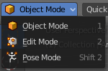
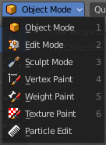
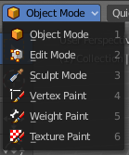
The Mode drop-down box allows you to switch between the different modes.
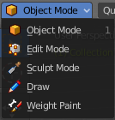
Modes are object states that allows you to edit and manipulate objects at different levels with different tool sets and goals. The sculpt mode for example allows you to sculpt a mesh object. Edit Mode allows to manipulate the mesh of the object, and so on.
The available modes can differ from object to object. An armature for example has an additional pose mode. And when you work with a grease pencil object, then several grease pencil modes becomes available.

Object Mode
This mode allows to manipulate objects at Object level. Like move it around, rotate it, etc. This mode is available for all object types.

Edit Mode
The edit mode allows to edit the object. With a mesh object this means that you are able to modify and to change the geometry. With an armature you build your skeleton. And with a text object you can type in text, and choose the font etc.
Not all objects has an edit mode.

Sculpt Mode
In this mode you can sculpt the mesh. This mode is available for mesh and grease pencil objects.

Vertex Paint
Vertex Paint is a mesh object only mode. In this mode you can paint vertices with colors.

Weight Paint
In this mode you can adjust weight painting for an armature for example. But Weight Painted mesh objects can also be used in conjunction with particles. Also a grease pencil stroke can be weight painted.

Texture Paint
Weight Paint is a mesh object only mode. In this mode you can paint at the texture of a mesh directly. This mode requires to have a working UV mapping and a texture at the mesh object.

Edit Strokes
Edit Strokes is a Grease Pencil only mode. It allows to manipulate the curves at a mesh level.

Particle Edit
Particle edit is a Particle System mode only. When you apply a particle system to a mesh object then this mode becomes available. It allows you to manipulate the particle system at a mesh level. You can comb hair particles for example.

Draw
Draw is a grease pencil object only mode. In this mode you draw grease pencil strokes.

Mesh Object Sub Modes

The different modes can have some sub modes. For example different selection methods in mesh edit mode. Or a mask mode for texture painting. The sub mode settings can be found right from the Modes drop down box.

Edit Mode - Mesh Select Modes
When you enter the edit mode with a mesh object then you will see the mesh select modes. They allows you to switch between the three available selection modes Vertice select, Edge Select and Face Select.
Vertex Select allows you to select vertices.
Edge Select allows you to select edges.
Face select allows you to select faces.
The mesh display changes, dependent of the mode. When you have for example select vertices active, then the vertices highlights at the mesh.
You can have more than one mode active by shift clicking at the other mesh select modes.

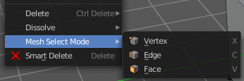
The standard Bforartists has hotkeys to switch between the modes. X, C and V. You cannot see or edit them at the header element. There is however a sub menu in the mesh menu, called Mesh Select Mode. Here you can see and edit the hotkeys.

Vertex Paint - Mask and Vertex Selection

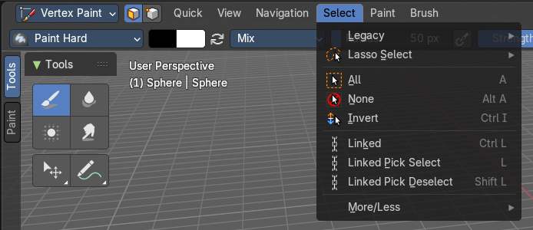
Paint Mask
When you activate this tool then you reveal a Select menu in the header. And you can select the mesh parts that you want to manipulate. Note that you may first want to deselect all. By default everything is selected ...
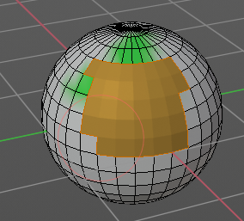
The select menu is explained in the chapter Vertex Paint modes. The menu items should be pretty self explaining though.

When you have selected a part of the mesh, then you can just paint the faces at this selected part. The edges are the border.

Vertex Selection
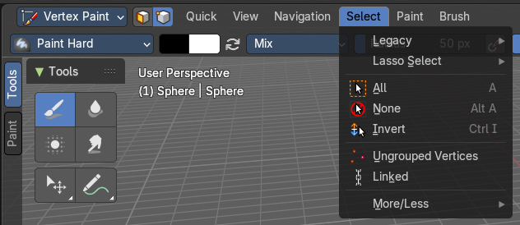
When you activate this tool then you reveal a Select menu in the header. And you can select the mesh parts that you want to manipulate. This tool is meant for Weight Painting. And so the mesh displays the vertices too.
Note that you may first want to deselect all. By default everything is selected ...
The select menu is explained in the chapter Vertex Paint modes. The menu items should be pretty self explaining though.
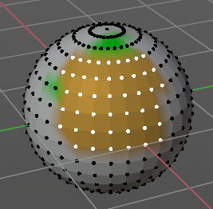
When you have selected a part of the mesh, then you can just paint the vertices at this selected part. The difference to the Paint mask method is that here the edges are not the border of the color. But there is a gradient between the vertices.

Weight Paint - Mask and Vertex Selection

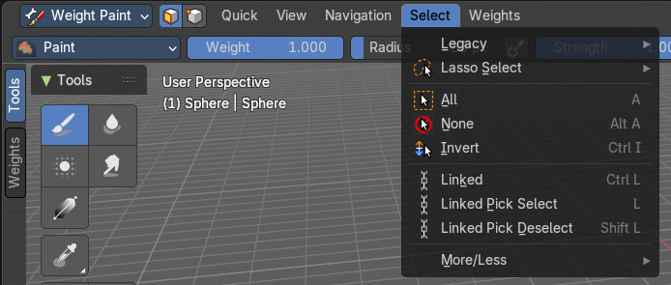
Paint Mask
Mesh Object.
When you activate this tool then you reveal a Select menu in the header. And you can select the mesh parts that you want to manipulate. Note that you may first want to deselect all. By default everything is selected ...
The select menu is explained in the chapter Vertex Paint modes. The menu items should be pretty self explaining though.
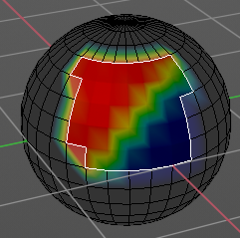
When you have selected a part of the mesh, then you can just paint the faces at this selected part. The edges are the border.

Vertex Selection
Mesh Object.
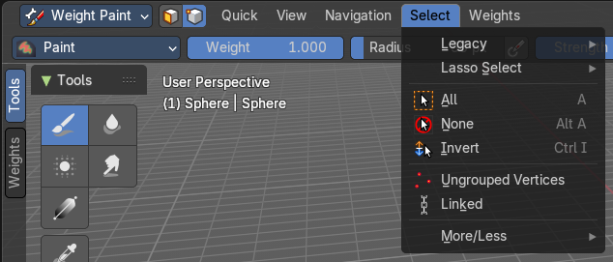
When you activate this tool then you reveal a Select menu in the header. And you can select the mesh parts that you want to manipulate. This tool is meant for Weight Painting. And so the mesh displays the vertices too.
Note that you may first want to deselect all. By default everything is selected ...
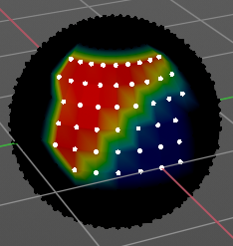
The select menu is explained in the chapter Vertex Paint modes. The menu items should be pretty self explaining though.
When you have selected a part of the mesh, then you can just paint the vertices at this selected part. There is no real difference to the faces method. The selection is the same.

Texture Paint - Mask Selection

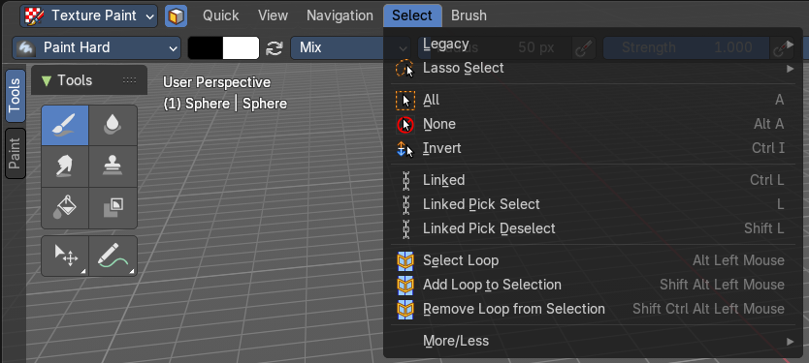
Paint Mask
Mesh Object.
When you activate this tool then you reveal a Select menu in the header. And you can select the mesh parts that you want to manipulate. Note that you may first want to deselect all. By default everything is selected ...
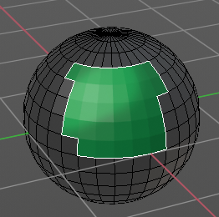
The select menu is explained in the chapter Vertex Paint modes. The menu items should be pretty self explaining though.
When you have selected a part of the mesh, then you can just paint the faces at this selected part. The edges are the border.

Particle Edit - Select Modes

Mesh Object with a particle system. You can just have one method active at a time.

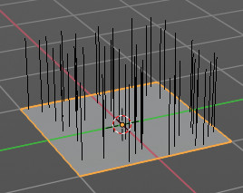
Path
No key points are visible, you can select/deselect only all particles.

Point
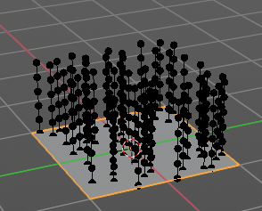
You can see, select and edit all key points of the particle paths.

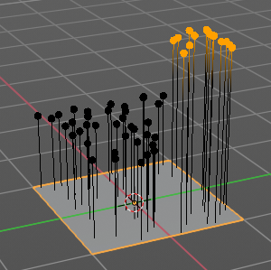
Tip
You can only see, select and edit the tip of the particles. This includes the brushes. The comb brush is a special case here. The other pat key points bends of course still in this mode. But affected by the brush is just the tip key.

Grease Pencil Sub Modes

The different modes can have some sub modes. For example different selection methods in mesh edit mode. Or a mask mode for texture painting. The sub mode settings can be found right from the Modes drop down box.

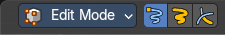
Edit Mode
The edit mode allows you to edit the grease pencil strokes.

Select Modes
You can only have one method active at a time.

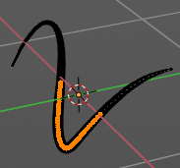
Select Only Points
When you for example border select some points of the stroke, then just this points gets selected.

Select all Stroke Points
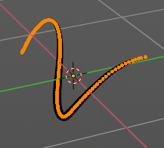
When you for example border select some points of the stroke, then the whole stroke gets selected.

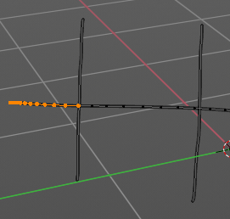
Select all Stroke Points between other strokes
When you for example border select some points of the stroke, and this stroke crosses another stroke, then the part of the stroke up to the crossing point gets selected.

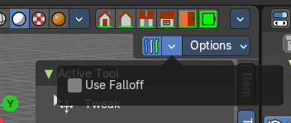
Multi-frame
When this mode is active, then you can edit strokes from multiple grease pencil frames at once. The key frames must be selected to be included.

Use Falloff
Multi frame has a setting, which becomes visible when the mode is active.
Use Falloff when edit in Multi frame mode to compute brush effect by frame.

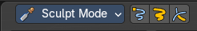
Sculpt Mode
The sculpt mode allows you to sculpt the grease pencil strokes.

Selection Mask Points
Just the selected vertices gets sculpted.

Selection Mask Strokes
Just the selected strokes gets sculpted.

Selection Mask other strokes
Only sculpt selected stroke points between other strokes.

Multi-frame
When this mode is active, then you can edit strokes from multiple grease pencil frames at once. The key frames must be selected to be included.

Use Falloff
Multi frame has a setting, which becomes visible when the mode is active.
Use Falloff when edit in Multi frame mode to compute brush effect by frame.

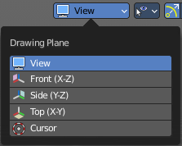
View
Relative to which plane to draw the strokes. Default orientation is view.

Draw Mode
The draw mode is the mode in which you draw the grease pencil strokes.

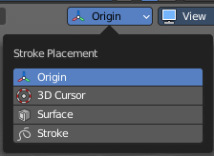
Origin
Where the stroke is placed.

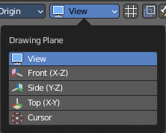
View
Relative to which plane to draw the strokes. Default orientation is view.

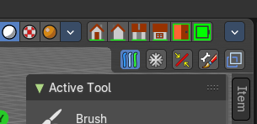
Multi-frame
When this mode is active, then you can edit strokes from multiple grease pencil frames at once. The key frames must be selected to be included.

Use Additive Drawing
When creating new frames, then the strokes from the previous or active frame gets included as the base for the new stroke.

Automerge
Join last drawn strokes by distance with previous strokes in the active layer.

Add Weight Data for new strokes
Add Weight data for new strokes, according to the current vertex group and weight. When no vertex group is selected, then no weight is added.

Draw Strokes on Back
Usually a new stroke is drawn on top of existing strokes. Draw Strokes on Back adds the new strokes below the existing strokes.

Weight Paint Mode

Multi frame
When this mode is active, then you can edit strokes from multiple grease pencil frames at once. The key frames must be selected to be included.

Use Falloff
Multi frame has a setting, which becomes visible when the mode is active.
Use Falloff when edit in Multi frame mode to compute brush effect by frame.

Vertex Paint Mode

Select Modes
You can only have one method active at a time.

Select Only Points
When you for example border select some points of the stroke, then just this points gets selected.

Select all Stroke Points
When you for example border select some points of the stroke, then the whole stroke gets selected.

Select all Stroke Points between other strokes
When you for example border select some points of the stroke, and this stroke crosses another stroke, then the part of the stroke up to the crossing point gets selected.

Multi frame
When this mode is active, then you can edit strokes from multiple grease pencil frames at once. The key frames must be selected to be included.

Use Falloff
Multi frame has a setting, which becomes visible when the mode is active.
Use Falloff when edit in Multi frame mode to compute brush effect by frame.

Geometry Node Group Tools
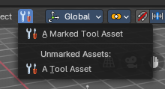
This header button menu with the tool icon is a container for Geometry Node Groups that have been set as “Tools” in the Geometry Nodes editor. These are act-once operators that now can be placed in the Geometry Node Group Tools or in custom entries in the 3D View header entries.
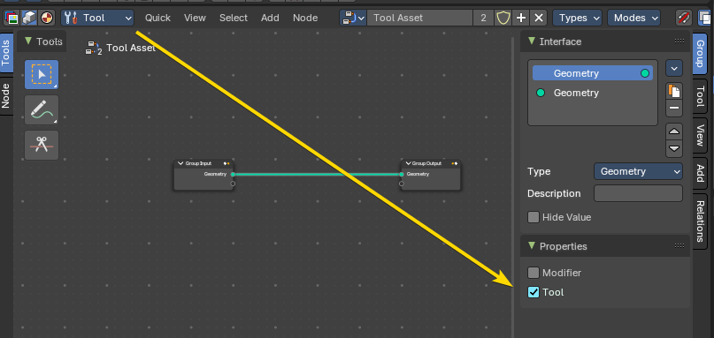
Example: here the Geometry Nodes has be switched to the Tool mode, and the node group Properites have been set to Tool. This node group will now show in the Geometry Node Group Tools header menu.

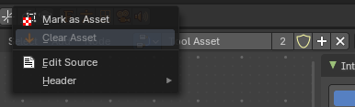
Marked Assets
A marked Geometry Nodes node group set as an asset and a tool will display here. To mark, right click on the geometry node selector in the Geometry Nodes editor, and mark as asset.

Unmarked Assets
A local unmarked Geometry Nodes node group set as a tool will display under the “Unmarked Assets:” label.

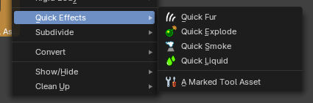
Marked Assets with assigned Asset Browser Category
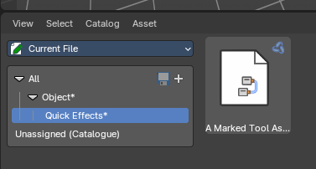
A marked node group set as a tool and as an asset and assigned to an Asset Browser category with the same category structure as the menu entry names will display as nested act-once operators.
Example: This is a marked-as-asset geometry node group with the name “A Marked Tool Asset” in the category “Object” then sub-category “Quick Effects”.

Object settings

The object settings just appears when the Tool Settings are hidden. This can be done in the View menu.

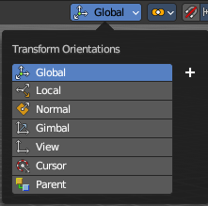
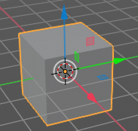
Transform Orientations
You can display Transform Manipulators at your object or selection by activating them in the tool shelf. They allow you to scale, rotate or move objects by grabbing their controls, and moving your mouse in the corresponding axis. The widget can be oriented in different ways by using another method in this drop down box. The names should be self explaining.

View
The transform orientation aligns to the current view.

Gimbal
Aligns each axis to the Euler rotation axis as used for input.

Normal
This is of interest for bones for example. Aligns the transformation axis to average normal of the selected elements. Bone Y axis for Pose mode.

Local
Uses the local orientation of the selected elements.

Global
Uses the global orientation for the selected elements.

Cursor
Uses the orientation of the 3D cursor.

Parent
Uses the orientation of the parent object.

Create Orientation
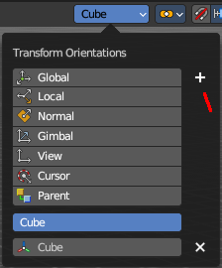
The create orientation button at the right adds a new orientation from the current mode and view. You can rename it.
This view is scene specific only. It does save and load with the current scene. But you cannot transfer it into another scene. When you create a new scene then this custom orientation is gone.
You can create more than one user orientation.

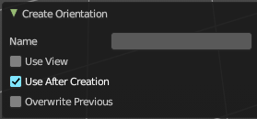
Last Operator Create Orientation
Create Orientation has some settings.

Name
Rename the orientation.

Use View
Use the current view instead of the active object to create the new orientation.

Use after creation
Use this orientation after creation.

Overwrite Previous
Overwrite previous created orientation in case it has the same name.

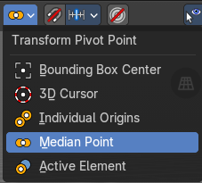
Transform Pivot Point
The Pivot Point is the center of your object or your selection. When you rotate or scale an object, or a group of vertices/edges/faces, you may want to shift the pivot point in 3D space. The names should be self explaining.

Bounding Box Center
Pivot around the bounding box center of selected objects.

3D Cursor
Pivot around the 3D cursor.

Individual Origins
Pivot around the center of each individual object.

Median Point
Pivot around the median point of selected objects.

Active Element
Pivot around the active element.

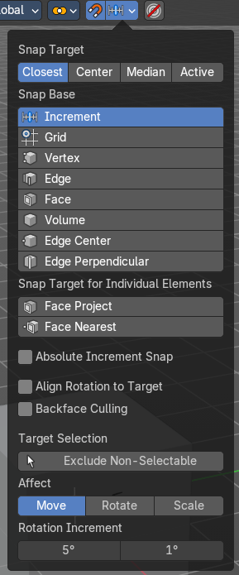
Snapping
Activate snapping when transforming an element.
Snapping can be temporarily activated by holding CTRL key. So no need to turn snapping on and off all the time.
You can snap to various scene elements in Object, Edit and Pose mode. And you can activate more than one snapping method by holding down CTRL and clicking at the next snapping element.

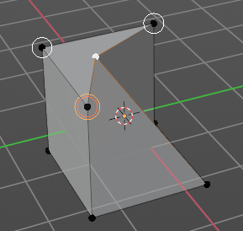
Multiple Snap Targets
When you move the mouse with snapping on and the element to snap selected (This does not work with holding CTRL), then you can press hotkey A to mark the current snapping point, then proceed to mark as many other snapping points as you wish. And the element that you want to snap will then be in the center of these marked snapping points. Marked snapping points will have a circle around.
Marking a point more than once will give it more weight in the averaged location.

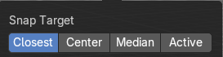
Snap Target
Which part to snap onto the target.

Closest
Snap closest point onto the target.

Center
Snap transformation center onto the target.

Median
Snap median onto the target.

Active
Snap active onto the target.

Snap to
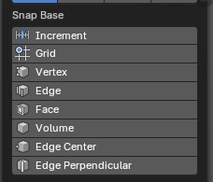
To which part of the target to snap.

Increment
Incremental grid snapping. In Orthographic view the snapping increment changes depending on zoom level.
Note: You can selected multiple by holding down the SHIFT key and selecting additional snap base modes.

Grid
Snap to a grid.

Vertex
Snap to a vertice.

Edge
Snap to an edge.

Face
Snap to a face.

Volume
Snaps to regions within the volume of the first object found below the mouse cursor.

Edge Center
Snaps to the center of an edge.

Edge Perpendicular
Snap to the nearest point of an edge.

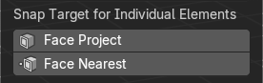
Snap Target for Individual Elements
Type of element for individual transformed elements to snap to.

Face Project
Snap by projecting onto faces.

Face Nearest
Snap to nearest point on faces.

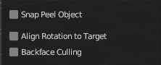
Snap Peel Object
Only available with the Snap to Method Volume. Consider objects as whole when finding a volume center.

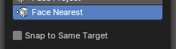
Snap to Same Target
Only available with the Snap Face Nearest. Snap only to target that the source was initially near.

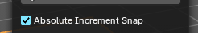
Absolute Increment Snap
Only available with Increment Snap mode, this will allow an absolute grid alignment while translating (based on the pivot center)

Align Rotation to Target
Align rotation with the snapping target.

Back face Culling
Exclude back facing geometry from snapping.

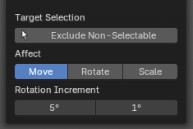
Target Selection
Align rotation with the snapping target.

Exclude Non-Selectable
Snap only onto objects that are selectable. This will ignore any objects that have been marked as un-selectable from the Outliner Editor.

Affect
Adjust what transform methods should be affected by snapping.
Note: You can selected multiple by holding down the SHIFT key and selecting additional transforms.

Move
Move the affected by snapping settings.

Rotate
Rotate the affected by snapping settings.

Scale
Scale the affected by snapping settings.

Rotation Increment
Snap in adjustable incremental steps.

Rotation Increment Slider
Angle used for rotation increments in the 3D editors.

Precision Rotation Increment Slider
Precision angle used for rotation increments in the 3D editors.

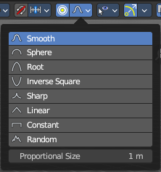
Proportional Editing
Enables proportional editing.
Proportional Editing is a way of transforming selected elements (such as vertices) while having that transformation affect other nearby elements with a falloff. For example, moving a single vertex will move unselected vertices within a given range. And the falloff means that selected vertices that are closer to the selected vertex will move more than those farther from it.

Settings
The settings appears when you activate Proportional Editing. Choose between different falloff methods for the proportional editing.

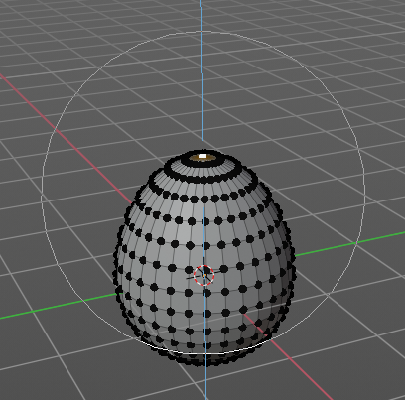
Proportional Size
The influence of the proportional editing is defined by a radius. It is by default one standard unit.
You can change the influence radius for proportional editing with the mouse wheel or the Page up Page down arrows while keeping the mouse button pressed down and do the translation.
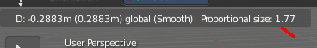
The exact radius value can be read in the header while transformation.
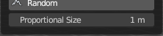
And it can also be read and edited at the Proportional Size slider in the Proportional Editing panel.

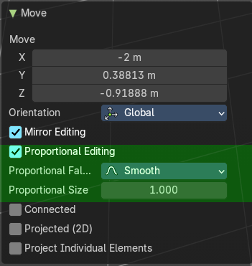
Last Operator Proportional Editing
When you translate an object, move it around or rotate or scale it, then the last operator contains also proportional editing settings.

Proportional Editing
Enable proportional editing.

Proportional Falloff
Adjust the falloff methods again.

Proportional Size
Adjust the falloff radius. Note that the white circle is not displayed when using this slider.

Connected
The proportional falloff gets calculated for connected parts only.

Projected(2D)
In depth direction along the view the radius is ignored. It selects as deep as there is something to select.

Selectability & Visibility
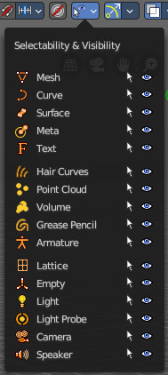
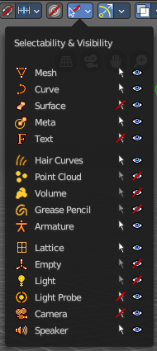
In this drop down box you can set specific elements in the scene to either not selectable or invisible.
When the elements are invisible then they are also not selectable.
When you have set some objects to not selectable or invisible, then the icon in the menu header changes.

Viewport Gizmo

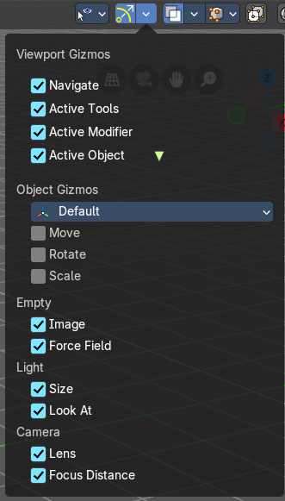
This menu allows you to adjust what gizmos shows. The button at the left turns them all off or on.

Show Gizmo
Shows or hides all available gizmos at once.

Gizmo Options
Turn on or off specific widgets.

Viewport Gizmos

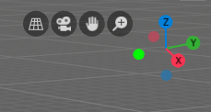
Navigate
Turn on or off the navigate widget. The navigate gizmo is the block of buttons and the widget up right.

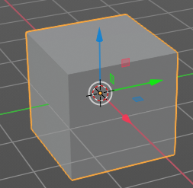
Active Tools
Turn on or off the active tool widget. When you activate one of the transformation buttons in the tool shelf, then a gizmo will appear at the object.

Active Modifier
Toggles the gizmos for the active Geometry Nodes modifier assets.

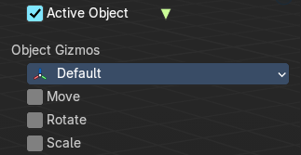
Active Object
Turn on or off the Object Gizmos. The Object Gizmos is an extra set of translate gizmos, similar to the active tool widget that shows when you activate one of the transform buttons in the tool shelf. These alternatively show the transform gizmos as permanent gizmos as long as you don't have another tool selected that overrides this widget.

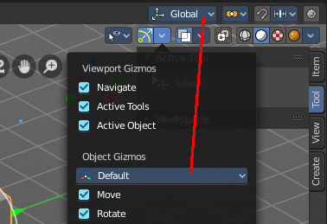
Object Gizmos

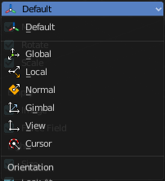
Transformation Orientation
Adjust the orientation of the widget. By default it uses the transform orientation from the viewport. This set can override the transform orientation.
You can have all transform methods on at once.

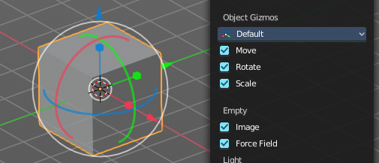
Move
Shows the move part of the widget.

Rotate
Shows the rotate part of the widget.

Scale
Shows the scale part of the widget.

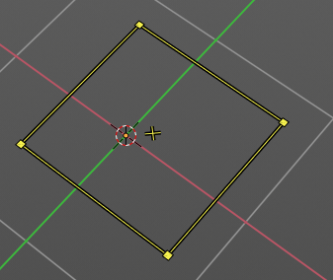
Empty

Image
Shows the transform gizmo at an empty of type Image. You need to hover with the mouse over the object to reveal the yellow gizmo.

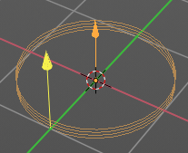
Force Field
Some force field types have a gizmo. Shows the transform gizmo at a force field.

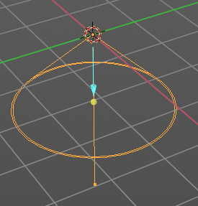
Light

Size
Show the gizmo to adjust the size of lights. That's the blue arrow here.

Look At
Show the gizmo to adjust the direction of the light. That's the yellow dot in the middle of the circle.

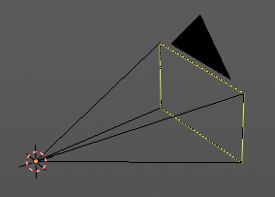
Camera

Lens
Show the gizmo to adjust the lens and orthographic size. The yellow square.

Focus Distance
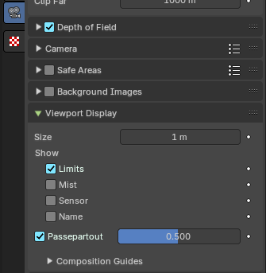
Shows the gizmo to adjust the focus distance.
You first need to turn on the Limits gizmo in the camera settings in the Viewport Display panel. Then you can turn off the focus distance gizmo part with Focus Distance.

Mesh Object - Sculpt mode

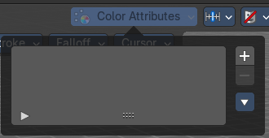
Color attributes panel
This panel also exists in the properties editor.
Currently this panel is greyed out and dysfunctional in Sculpt mode. It is WIP.

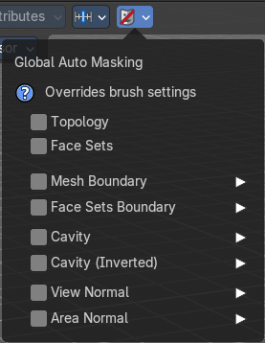
Global Auto Masking
These override all brush settings, but you can also set these auto masking features per brush.

Topology
Affect only vertices that are connected to the current active vertex under the brush.

Face Sets
Affect only vertices that share face sets with the active vertex.

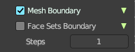
Mesh Boundary
Do not affect non manifold boundary edges.
The setting that appears on activation and is valid for both, Mesh Boundary and Face Sets Boundary.

Face Sets Boundary
Do not affect vertices that belong to a face set boundary.
The setting that appears on activation and is valid for both, Mesh Boundary and Face Sets Boundary.

Steps
Distance where boundary edge automasking is going to protect vertices from the fully masked edge.

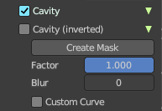
Cavity
Do not affect vertices on peaks. This feature is based on the surface curvature.
The setting that appears on activation and is valid for both, Cavity, and Cavity (Inverted).

Cavity (Inverted)
Do not affect vertices in valleys. This feature is based on the surface curvature.
The setting that appears on activation and is valid for both, Cavity, and Cavity (Inverted).

Create Mask
Creates a mask based on the curvature of the surface.

Factor
The contrast of the cavity mask.

Blur
The number of times the cavity mask is blurred

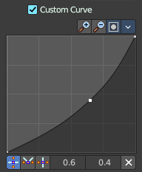
Custom Curve
Use a custom falloff curve for the cavity mask.


Selecting Points
You can select curve points. This reveals two edit boxes for the x and y coordinate of this point.
Selected points can be moved around. Left click at them, hold the mouse button down and move them to a new location.


Adding Points
You can add new curve points by simply left clicking at the curve. Move the mouse to position them where you need it.

Navigation elements
The navigation elements at the top are described from left to right.

Zoom in and out
The two buttons with the magnifying glass at it zooms in and out in the curve window.

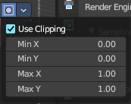
Clipping Options
Set up clipping for the stroke.

Use Clipping
Turns clipping on or off.

Min and Max X Y
The values for the clipping area.

Tools
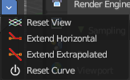
Tools is a menu where you can find some curve related tools.

Reset View
Resets the curve windows zoom.

Extend horizontal
Extends the curve before the first curve point and after the last curve point horizontally.

Extend extrapolated
Extends the curve before the first curve point and after the last curve point extrapolated.

Reset Curve
Resets the curve to the initial shape.

Handle Types
Sets the handle type for the current selected curve point.

X Y Position
The position of the current active curve point.

Delete Points
Deletes the current active curve point.

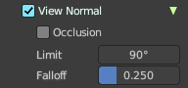
View Normal
Affect only vertices with a normal that faces the viewer.

Occlusion
Only affect vertices that are not occluded by other faces. With Occlusion on the Limit and Falloff options are not available.

Limit
View normal limit. The range of angles that will be affected.

Falloff
Extend the angular range with a falloff gradient.

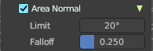
Area Normal
Affect only vertices with a similar normal to where the stroke starts.

Limit
Area normal limit. The range of angles that will be affected.

Falloff
Extend the angular range with a falloff gradient.

Mesh Object - Vertex Paint mode

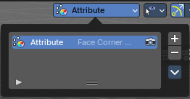
Color Attributes panel
This panel also exists in the properties editor.
In vertex paint mode and sculpt mode you can paint vertices of a mesh with a color. This will create a vertex color index. You can see and manage this vertex color indexes in the Vertex Colors panel.
Vertex colors can for example be used to mix shaders together. Or also directly render them. In the shader editor color attributes can be used by the Attribute node.
A mesh can have more than one vertex color index and type. But just one index can be the active one.

Active Color Index
A List of the vertex color indexes for this mesh.

Color index name
The name of the vertex color index. It can be renamed by double clicking at it.

Active Render
Set this vertex color index as the one to render. Just one vertex color index can be active at a time. But you can use another vertex color index in a material.

Drag Handler
The two vertical lines at the end is a handler with which you can expand the list.

Search Field

You can expand a search field at the bottom of the list. Type in your term and hit enter to filter for your term.

Invert
Exclude the search term instead of searching for it.

Sort by Name
Sort the List by name.

Add +
Create a vertex color index.

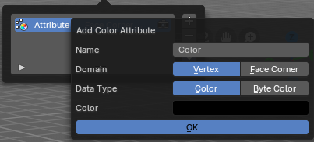
Add Color Attribute Popup

Name
The name of the color attribute index.

Domain
The domain of the color attribute.
- Vertex stores the color attribute data in the vertices of the mesh data
- Face Corner stores the color attribute data in the face corners of the mesh data

Data Type
The the color attribute type.
- Color stores RGBA color 32-bit floating point values
- Byte Color stores RGBA color 32-bit positive integer values

Color
The Default fill colour

Ok
Confirm to apply

Remove -
Delete the selected vertex color index.

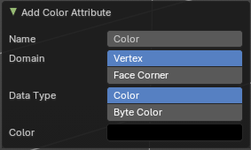
Adjust last operator Add Color Attribute
This is basically the same content as above. Minus the OK button.

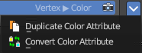
Specials menu

Duplicate Color Attribute
Duplicates the selected color attribute.

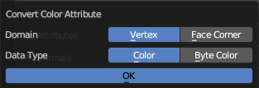
Convert Color Attribute
Convert a color attribute domain and data type. This tool calls a popup where you can choose what to convert.

Mesh Object - Weight Paint mode

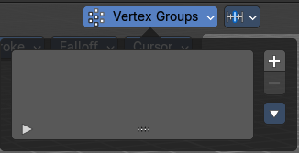
Vertex Groups
This panel also exists in the properties editor.
A Vertex group is a group of vertices, a selection of the mesh. It is for example used to weight a specific mesh part to a bone. Or to control the growth of hair particles.
This panel allows you to manage and edit vertex groups. Weight painting creates vertex groups automatically.
In Edit mode this panel shows some further controls.
Vertex groups exists for mesh and lattice objects.

Active Vertex Group list
A List of the vertex groups for this mesh.

Group name
The name of the group. It can be renamed by double clicking at it.

Lock
The lock icon at the end of a group name locks the group from being editable.

Drag Handler
The two vertical lines at the end is a handler with which you can expand the list.

Search Field
You can expand a search field at the bottom of the list. Type in your term and hit enter to filter for your term.

Invert
Exclude the search term instead of searching for it.

Sort by Name
Sort the List by name.

Add +
Create an empty vertex group.

Remove -
Deletes the active vertex group.

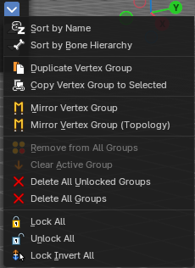
Specials menu

Sort by Name
Sorts the vertex groups alphabetically by name.

Sort by Bone Hierarchy
Sorts the vertex groups by the hierarchy of the assigned bones.

Duplicate Vertex Group
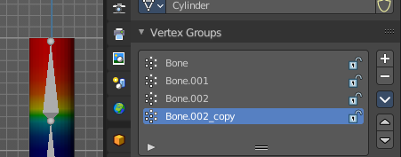
Add a copy of the active vertex group as a new group. The new group will be named like the original group with “_copy” appended at the end of its name. And it will contain associations to exactly the same vertices with the exact same weights as in the source vertex group.

Copy Vertex Group to Selected
Copy all vertex groups to other selected objects provided they have matching indices (typically this is true for copies of the mesh which are only deformed and not otherwise edited).

Mirror Vertex Group
Mirrors weights and/or flips group names from one side of a symmetrical mesh to the other.
Only mirroring along local X axis is supported. Vertices that have no corresponding vertex on the other side will not be affected. Note, the weights are not transferred to the corresponding opposite bone weight group.

Mirror Vertex Group (Topology)
Performs the Mirror Vertex Group with the Topology Mirror option enabled.

Remove from All Groups
Unassigns the selected vertices from all groups. Even locked.

Clear Active Group
Remove all assigned vertices from the active group. The group is made empty. Note that the vertices may still be assigned to other vertex groups of the object. This feature does not affect locked groups.

Delete All Unlocked Groups
Remove all vertex groups from the object that are not locked.

Delete All Groups
Remove all vertex groups from the object.

Lock All
Lock all groups.

Unlock All
Unlock all groups.

Lock Invert All
Invert group locks.


Move Vertex Group Up / Down
Moves the selected vertex group up or down in the list.

Mesh Object - Texture Paint mode

Texture Slots

The texture slots panel allows you to manage the textures that you use for texture painting. When the mesh doesn't have a texture yet to paint at, then you get a hint about a missing texture. No Textures. The Add Texture Paint Slot button allows you to add one. Base Color allows you to create a diffuse map.
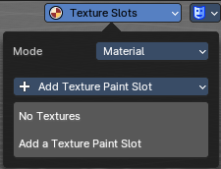
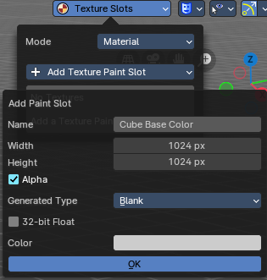
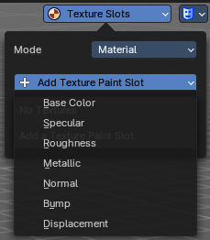
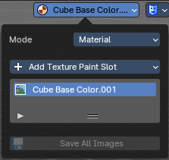

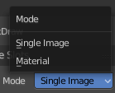
Mode
Choose in which mode you want to paint. Single Image just works with a single image, without any material.
Material works with a material and a texture. The texture is here part of the material.

Add Texture Paint Slot
Here you can choose what type of texture you want to add for texture painting.

The texture gets added to the shader, and connected to the correct node. A base color is meant for diffuse, and so it connects with the base color slot.
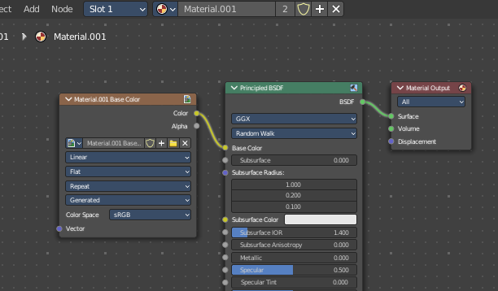

Paint Slot with mode Material

Material Paint Slot
A list of the available paint slot materials.

Add Texture Paint Slot
The + button at the right. Add more materials to the Material Paint Slot.

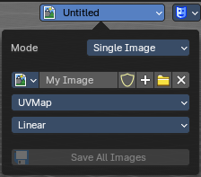
Paint Slot with Mode Single Image

Image List
A list of the available images, which allows you choose one in case one exists.

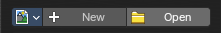
New/Open
When no image is loaded then you can create a new image here, or load a new image.

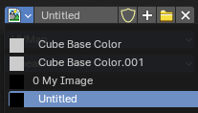
Edit Box
See the name of the image, and edit the name.

Fake User
When enabled then this image will be stored internally. But not the painted changes at it!!

New Image
Create a new image.

Open Image
Open an image

Unlink Data Block
Delete the Image when saving the scene, closing and reopening Bforartists. Note that the number of Users must be zero. Or the image comes back.

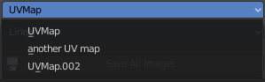
UV Map
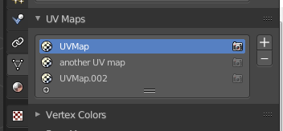
Choose a UV map to work with. Usually there is just one. But there can be more than one UV map. You can add and manage more in the Object data tab in the UV Map panel.

Interpolation
Set the interpolation type. Linear or Closest.

Save all Images
Saves all images. Internal images needs to be saved manually first. They don't have a path yet to which they could be saved. You will get an invalid path warning.

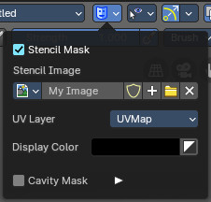

Stencil Mask
Stencil mask allows mask painting with a stencil map. It is a sub menu tab. In expanded state it shows the falloff curve, which can be edited.

Activate Stencil map
Activates the stencil map.

Stencil Image
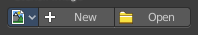
Choose or load your stencil texture.

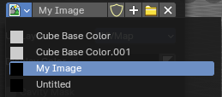
Texture browser
Here you will find a list of currently loaded textures.

Edit Box
The currently active stencil texture.
The number right of it, in this case 2, indicates how much number of users ( internally ) this brush uses. This means that this data block (the brush) shares currently settings with at least one other object. Most probably the parent brush where we have created it from. Click at the value to make this brush a single user. The button will vanish then.
The shield icon button set the brush to have a fake user. Zero user data-blocks are normally not saved. But sometimes you want to force the data to be kept even when the data block has no user.
The + button allows you to add a new pencil with the current settings. Note that the brushes are NOT saved when you close Bforartists. You can save them into the current blend file. Or you can save the startup file. But be careful here. This saves everything else of the current state of Bforartists too.
The X button deletes the brush as the active one. It does NOT delete it from the brushes list.

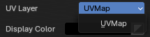
UV Layer
At which UV map the stencil texture is active.

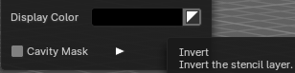
Display Color
The stencil color in the viewport.

Invert the stencil color
Inverts the stencil color.

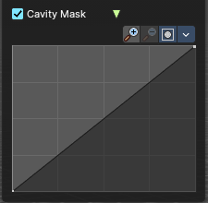
Cavity Mask
Cavity mask allows mask painting according to mesh geometry cavity. It is a sub menu tab. In expanded state it shows the falloff curve, which can be edited.

Activate Cavity mask
Activates the Cavity mask.

Navigation elements
The navigation elements at the top are described from left to right.

Zoom in and out
The two buttons with the magnifying glass at it zooms in and out in the curve window.

Zoom in and out
The two buttons with the magnifying glass at it zooms in and out in the curve window.

Tools
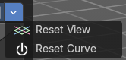
Tools is a menu where you can find some curve related tools.

Reset View
Resets the curve windows zoom.

Reset Curve
Resets the curve to the initial shape.


Use Clipping
Clipping options. Set up clipping for the stroke.

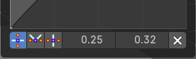
Vector Handle
Set handle type to Vector.

Auto Handle
Set handle type to Auto.

Auto Clamped Handle
Set handle type to Auto Clamped.

X / Y
The x and y position of the selected point.

Delete Points
Deletes selected curve points.

Curve Object - Edit Mode

Set Handle Type
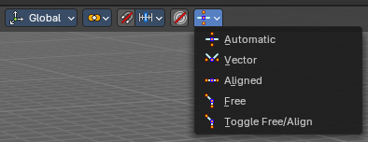
Handles defines the type of handle for the control points of the curve. You have the choice between Auto, Vector, Align and Free. And the Last Operator gives you a fifth possibility to toggle between Free and Align.

Auto
Auto aligns the handles automatically.

Vector
Set Handle type to Vector.

Align
Set Handle type to Align.


Free
Set Handle type to Free.

Toggle Free/Aligned
Toggle Free/Aligned.


Last Operator Set Handle Type

Type
Type is a drop-down box where you can set the handle type. You have the choice between Auto, Vector, Align, Free. And the fifth possibility toggles between Free and Align.

Viewport Overlays - all modes
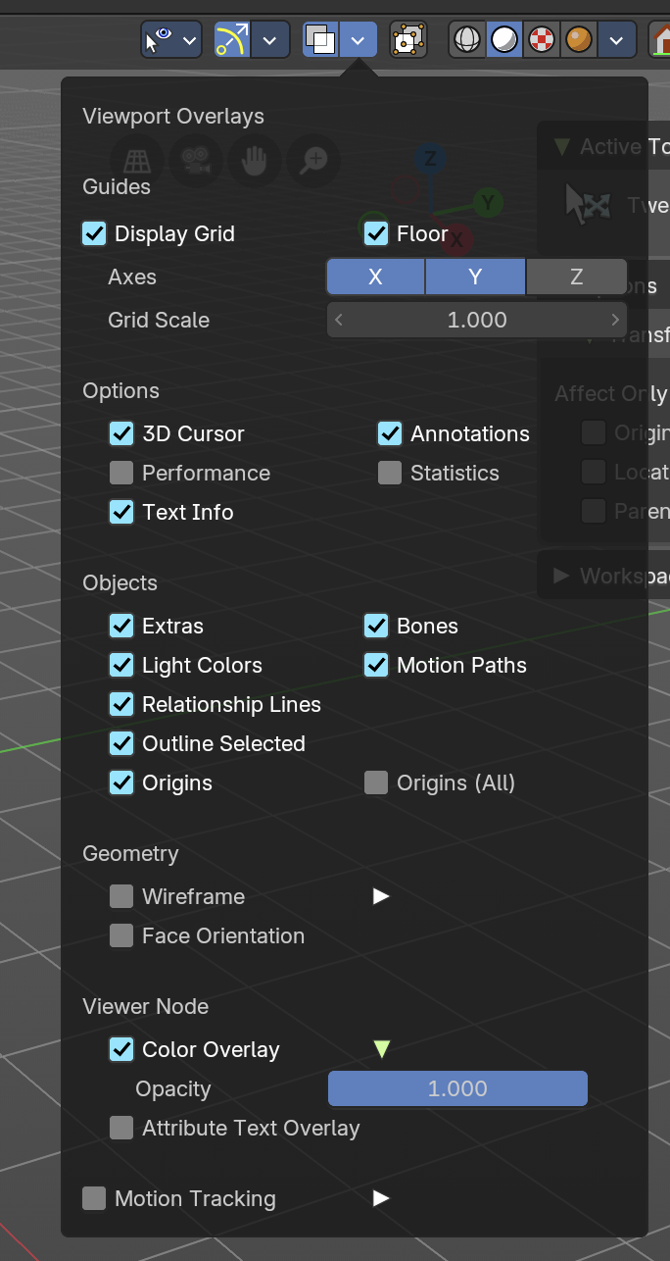
Turn on or off all overlays. This includes the ground grid, things like relationship lines, and several other elements in the viewport. Some content is available in all modes. Some content is changing, dependent of the mode you are in. In Edit mode with a mesh object you will get some normal functionality for example.

Guides

Grid
Show the whole ground grid, including axes. You can also show the grid in orthographic mode of the viewport.

Floor
Show the ground grid, the white part of it.

Axes
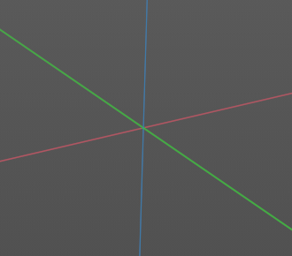
Show the colored axis lines in the 3d view
( now works in both perspective / orthographic Views).

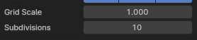
Scale
Scale the ground grid. This works in perspective and orthographic view.

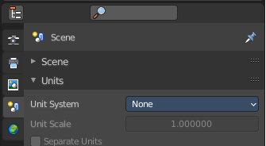
Subdivisions
Subdivisions just shows with a Unit system of None. It allows you to subdivide the ground grid.

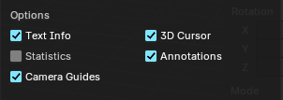
Options

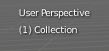
Text Info
In the upper left corner of the 3D view there is a text info string, which can be hidden here. It tells you in what view you are, what is selected, and things like frames per second when you play an animation

Annotations
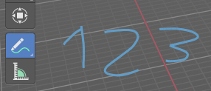
Show or hide annotations. Annotations can be drawn at the 3D View with the annotation tool in the tool shelf.

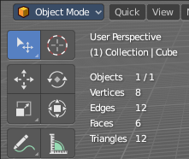
Statistics
Displays statistical informations in the upper left corner of the 3d viewport. Object count, vertices, and so on.

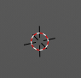
3D Cursor
Show or hide the 3D cursor. That's the white red circle in the center of the viewport.

Camera Guides
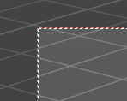
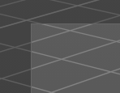
Just in Camera mode.
Display the dotted line around the inside of the passepartout.

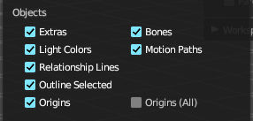
Objects

Extras
Show or hide object details. Including things like empty wires like lights, cameras, and other visual guides.

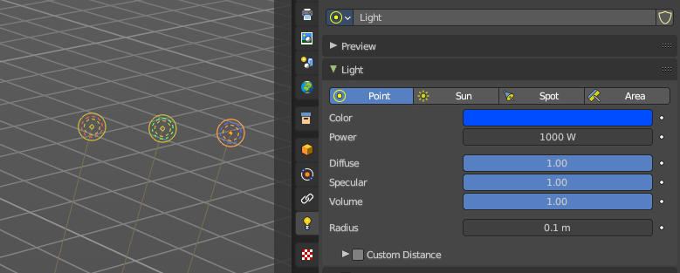
Light Colors
Displays the light widget in the color of the light.

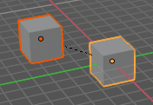
Relationship Lines
Show or hide relationship lines. When you for example parent one object to another then you will see a dotted line. The relationship line.

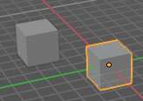
Outline Selected
Show the selected object with an outline

Bones
Show or hide bones.

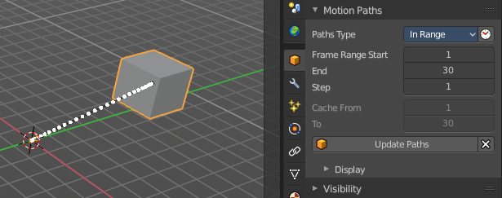
Motion Paths
Show or hide motion paths. Motion paths can be calculated in the Motion Paths panel. You need an animation for that.

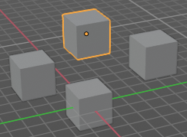
Origins
Show or hide the origin of the selected object. The origin is the center point of the object, and represented by an orange dot.

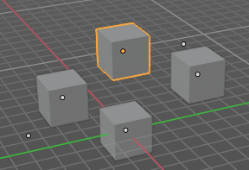
Origins(All)
Show or hide the origin of all objects. Even from hidden ones. The not selected objects shows the center point with a white dot.

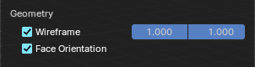
Geometry
Geometry related settings.

Wire frame
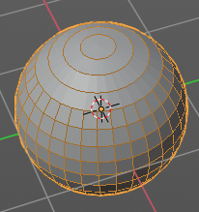
Show the wire frame in object mode.

Wireframe Threshold
With a wire frame value of 1 all edges are drawn. The lower the value, the more edges will disappear.

Opacity
The opacity of the displayed edges.

Face Orientation
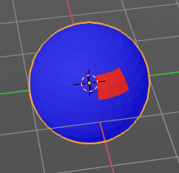
This mode allows to check for faces with flipped normals, which cannot be seen with the defaults. Blue is pointing outwards, red is pointing inwards.

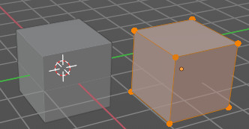
Fade inactive Geometry
Edit mode feature, does not show in other modes. Fades the not active geometry, the not selected scene objects, towards a plain grey. In Object mode this setting has no effect.

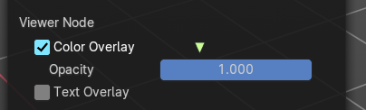
Viewer Node
Viewer node related settings.

Color Overlay
Enable color overlay in viewport for geometry attributes that are connected to an enabled Geometry Nodes’ viewer node.

Opacity
The opacity of the color overlay mentioned above.

Text Overlay
Show geometry attribute values that are connected to an enabled Geometry Nodes’ viewer node as text in viewport. This option just shows when you have geometry nodes at the object, and there is a viewer node in the tree. Example with index values:
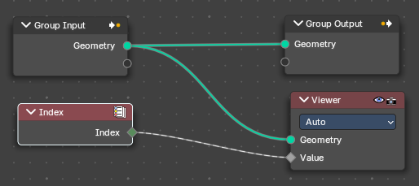
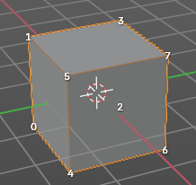
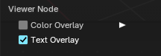

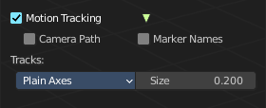
Motion Tracking
Motion tracking related settings. When you turn it on, then some further options appears. These features just shows before you bake the solution. Not with the resolved solution.

Camera Path
Shows the camera path.

Marker Names
Shows the marker names.

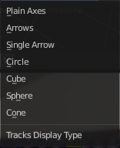
Track display type
How to display the tracks.

Track size
Adjust the display size of the tracks of reconstructed data

Viewport Overlays - Mesh Object - Edit Mode
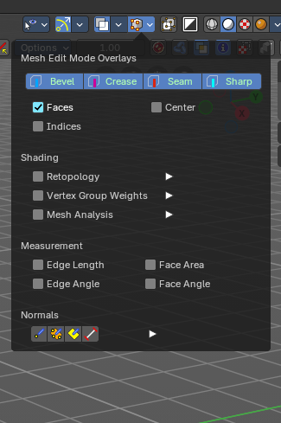
The Viewport Overlays panel shows different content, dependent of mode and object type. This is with mesh object in edit mode.

Mesh Edit Mode Overlays

Bevel
Display weights created for the Bevel Modifier.

Crease
Display edges marked with a crease for the Subdivision Surface Modifier.

Seam
Display the UV unwrapping seams.

Sharp
Display sharp edges, used with the edge split modifier.

Faces
Highlight faces by using a face overlay that applies to both selected and unselected faces.
This affects all selection modes.

Center
Show face-center points in solid shading modes. This is disabled in wireframe and xray mode.
Only affects face-select mode.

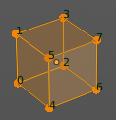
Indices
Display the indices of selected vertices, edges and faces at the mesh.

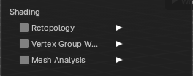
Shading

Retopology
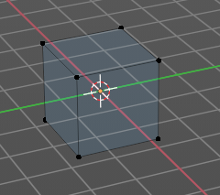
Hides the solid mesh and offset the overlay towards the view to make retopology easier. The selection is occluded by inactive geometry. You have to enable X-ray.

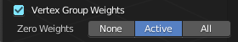
Vertex Groups Weights
Display weights in Edit Mode. When you activate this feature then further options appears.

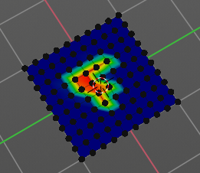
Zero Weights

None
Don't show the vertices with zero weights with a specific color. They appear blue like vertices with a very low weighting.

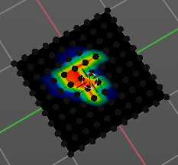
Active
Zero weights vertices are shown with a black color in the active vertex group.

All
Zero weights vertices are shown with a black color in all vertex groups of the mesh.

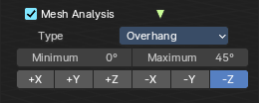
Mesh Analysis
Show the mesh analysis overlay and settings. Note that editing may be slow with mesh analysis tools on. And modifiers can make trouble.

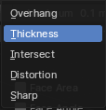
Type
The mesh analysis type.

Overhang
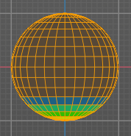
Extrusion 3D printers have a physical limit to the overhang that can be printed. The Overhang type shows the overhang in different ways. Angle and axis can be adjusted.

Minimum/Maximum
Minimum/Maximum angle to display.

Axis
Choose which angle to calculate.

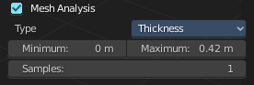
Thickness
3D Printers have a limited wall-thickness. Too thin areas cannot be printed. This mode displays thin areas as red.

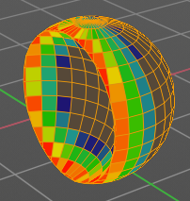
Minimum/Maximum
Minimum/Maximum thickness to display.

Samples
The number of samples to use to calculate the thickness.

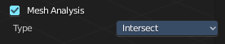
Intersections
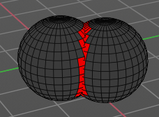
A mesh can be made of more than one closed sub mesh. Join two spheres and you have one mesh with two closed sub meshes. Such intersections can be a problem with printing. Intersect marks intersecting areas with red.

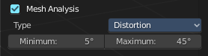
Distortion
Marks distorted faces.
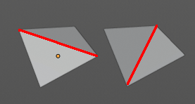
Distorted geometry, means uneven quads or N-gons, can cause problems with printing. Since the triangulation of a distorted quad or N-gon is undefined. And printing works with tris. With a quad there are already two solutions in which direction the edge to triangulate the face can point.

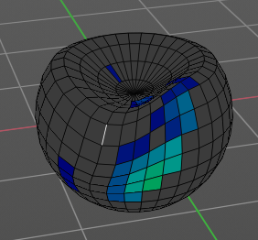
Minimum/Maximum
Adjust the minimum and maximum values after which a face gets displayed as distorted.

Sharp Edges
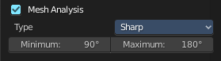
Similar to wall-thickness, sharp edges can be too thin to be able to print.

Minimum/Maximum
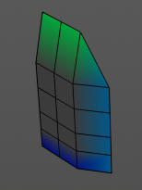
Adjust the minimum and maximum values after which an edge gets displayed as sharp.

Measurement
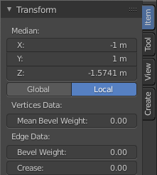
Shows measure values at the selected elements. The units are displayed as chosen in the preferences. These values respects global/ local in the transform panel. And so the values can differ when you have scaled the mesh in object mode, and the scaling is not applied yet. Use Global to take the object scale into account.

Edge Length
Shows the length of selected edges.

Edge Angle
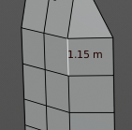
Shows the angle of selected edges between two faces.

Face Area
Show the area of selected faces.

Face Angle
Show the angle of selected face corners.

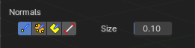
Normals
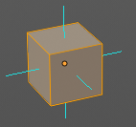
Show the normals for the chosen elements. They will be displayed as lines.

Display vertex normals
Displays the normals of the vertices

Display split normals
Displays the per vertex face normals

Display normals
Displays the face normals.

Constant Screen Size Normals
Display the normals either in size relative to the object. Or constant to the screen size.
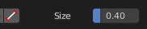
Relative to the object is measured in object units. Absolute to the screen size is measued in pixels.

Size
Adjust the length of the line that represents the normal.

Freestyle
Freestyle is the line renderer integrated into Bforartists. For freestyle you can mark edges and faces.

Edge Marks
Display Freestyle edge marks, used with the Freestyle renderer.

Face Marks
Display Freestyle face marks, used with the Freestyle renderer.

Viewport Overlays - Mesh Object - Sculpt Mode

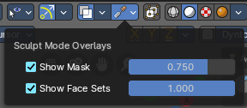
Show Mask
Show mask as overlay on object. The opacity of the overlay can be controlled by the slider.

Show Face Sets
Show face sets as overlay on object. The opacity of the overlay can be controlled by the slider.

Viewport Overlays - Mesh Object - Vertex Paint Mode

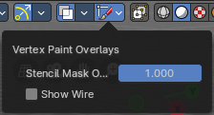
Opacity
How strong the painted color gets shown.

Show Wire
Display the wire at the mesh. Normally the wire is hidden.

Viewport Overlays - Mesh Object - Weight Paint Mode

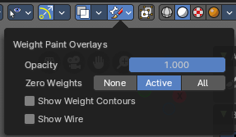
Opacity
The opacity of the color overlay.

Zero Weights

None
Don't show the vertices with zero weights with a specific color. They appear blue like vertices with a very low weighting.

Active
Zero weights vertices are shown with a black color in the active vertex group.

All
Zero weights vertices are shown with a black color in all vertex groups of the mesh.

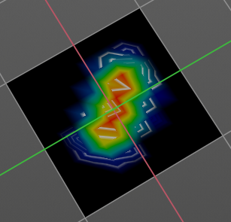
Show Weight Contours
Show contour lines formed by points with the same interpolated weight.

Show Wire
Display the wire at the mesh. Normally the wire is hidden.

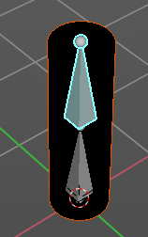
Show Bone X Ray
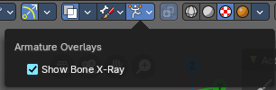
This prop just shows when you have both, the bone and the mesh object selected by holding down shift, and switch to weight paint.
This has in general the same effect than draw in front. It shows the bones on top of the mesh geometry.

Viewport Overlays - Mesh Object - Texture Paint Mode

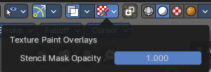
Stencil Opacity
How strong the painted color gets shown.

Viewport Overlays - Hair Object - Sculpt Mode

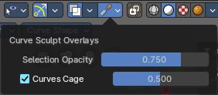
Selection Opacity
How solid not selected curves are displayed. Note that you can't make them fully transparent.

Curves Cage
Highlight the selected curves.

Cage Opacity
How strong selected curves are highlighted.

Viewport Overlays - Armature in Pose Mode

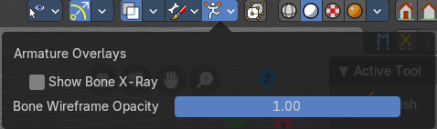
Show Bone X Ray
This has in general nearly the same effect than draw in front. It shows the bones on top of the mesh geometry. But you can fade the mesh geometry to black.

Bone Wireframe Opacity
The maximum opacity of bones in wireframe display mode.

Viewport Overlays - Grease Pencil

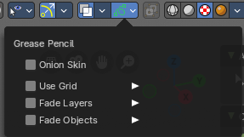
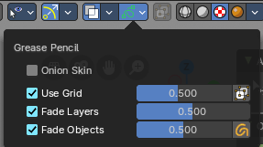
In Object Mode

Onion Skin
Show ghosts of the key frames before and after the current frame.

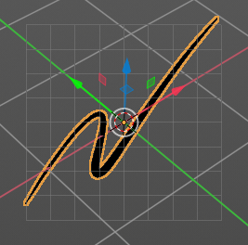
Canvas
Display a grid over Grease Pencil drawing plane. The opacity of the grid can be controlled with a slider.

Canvas X Ray
Show the grid in front of the stroke.

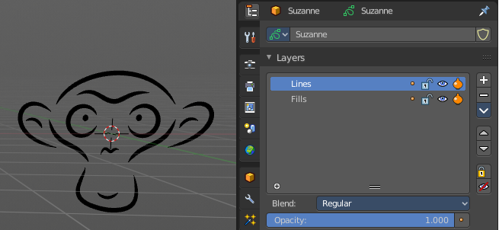
Fade Layers
Controls the opacity of the not selected layers in the current grease pencil object.
I have set the fade layers opacity to 1 here. When you select the other layer, then the inner part becomes visible again, and the black outlines hides.

Fade Objects
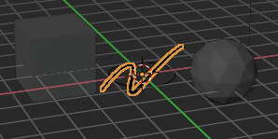
Fades everything in the viewport but the grease pencil color to black.

Fade Grease Pencil Objects
Fades the not active grease pencil objects to black too.

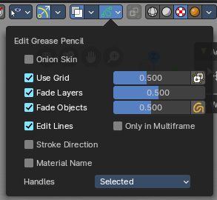
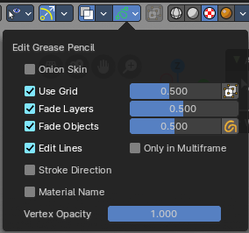
In Edit Mode

Onion Skin
Show ghosts of the key frames before and after the current frame.

Canvas
Display a grid over Grease Pencil drawing plane. The opacity of the grid can be controlled with a slider.

Canvas X Ray
Show the grid in front of the stroke.

Fade Layers
Control the opacity of the not selected layers in the current grease pencil object.
I have set the fade layers opacity to 1 here. When you select the other layer, then the inner part becomes visible again, and the black outlines hides.

Fade Objects
Fades everything in the viewport but the grease pencil color to black.

Fade Grease Pencil Objects
Fades the not active grease pencil objects to black too.

Edit Lines
Show the edges of the curve when editing strokes.

Stroke Direction
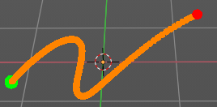
Shows a red and a green dot at the end of the stroke. Green dot is start. Red dot is end.

Only in multi frame
Only show edges of the curve while in multi frame edition.

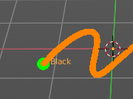
Material Name
Displays the material name at the start of the stroke.

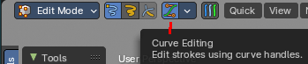
Vertex Opacity
With Curve Editing off. How strong the selected vertices of the stroke shows.

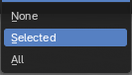
Handles
With Curve Editing on. Limit the display of curve handles in edit mode.

None
Don't limit the handles.

Selected
Just limit the selected handles.

All
Limit all handles.

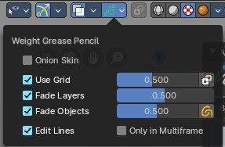
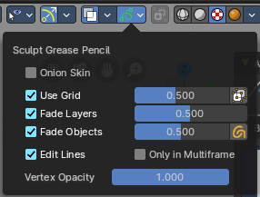
In Sculpt and Weight paint Mode

Onion Skin
Show ghosts of the key frames before and after the current frame.

Canvas
Display a grid over Grease Pencil drawing plane. The opacity of the grid can be controlled with a slider.

Canvas X Ray
Show the grid in front of the stroke.

Fade Layers
Control the opacity of the not selected layers in the current grease pencil object.
I have set the fade layers opacity to 1 here. When you select the other layer, then the inner part becomes visible again, and the black outlines hides.

Fade Objects
Fades everything in the viewport but the grease pencil color to black.

Fade Grease Pencil Objects
Fades the not active grease pencil objects to black too.

Edit Lines
Show the edges of the curve when editing strokes.

Only in multi frame
Only show edges of the curve while in multi frame edition.

Vertex Opacity
Sculpt mode only. How strong the selected vertices of the stroke shows.

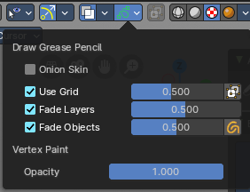
In Draw Mode

Onion Skin
Show ghosts of the key frames before and after the current frame.

Canvas
Display a grid over Grease Pencil drawing plane. The opacity of the grid can be controlled with a slider.

Canvas X Ray
Show the grid in front of the stroke.

Fade Layers
Control the opacity of the not selected layers in the current grease pencil object.
I have set the fade layers opacity to 1 here. When you select the other layer, then the inner part becomes visible again, and the black outlines hides.

Fade Objects
Fades everything in the viewport but the grease pencil color to black.

Fade Grease Pencil Objects
Fades the not active grease pencil objects to black too.

Vertex Opacity
How strong the selected vertices of the stroke shows.

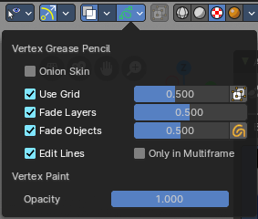
In Vertex Paint mode

Onion Skin
Show ghosts of the key frames before and after the current frame.

Use Grid
Display a grid over Grease Pencil drawing plane. The opacity of the grid can be controlled with a slider.

Canvas X Ray
Show the grid in front of the stroke.

Fade Layers
Control the opacity of the not selected layers in the current grease pencil object.
I have set the fade layers opacity to 1 here. When you select the other layer, then the inner part becomes visible again, and the black outlines hides.

Fade Objects
Fades everything in the viewport but the grease pencil color to black.

Fade Grease Pencil Objects
Fades the not active grease pencil objects to black too.

Edit Lines
Show the edges of the curve when editing strokes.

Only in multi frame
Only show edges of the curve while in multi frame edition.

Vertex Opacity
How strong the selected vertices of the stroke shows.

Opacity
The vertex paint opacity.

Viewport Shading

At the very right of the header you can find the viewport shading settings. Here you adjust the display of the viewport. The order goes from left to right.

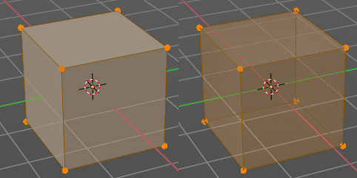
Show X Ray
This viewport setting is connected with the viewport shading. It allows you to show and edit the back geometry. Or hide it, so that you can just edit the geometry that points forwards.

Viewport Shading
Defines how geometry gets displayed in the viewport.

Wire frame
Displays the content in the viewport as Wire frame.

Solid
Displays the content in the viewport with a solid white color.

Material
Displays the content in the viewport with all material settings and with OpenGL rendering. Note that this does not exist when you choose the Workbench renderer.

Rendered
Displays the content in the viewport like you would have rendered it. This mode is dependent of what render engine you have currently active.

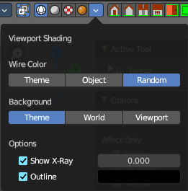
Viewport Shading Settings
The viewport shading panel. Its settings changes, dependent of which viewport shading mode you have activated. And provides you with further settings for it.

Viewport Shading Settings with Wire frame

Color

Single
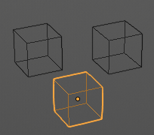
The selected object gets highlighted. The wire frame is the color of the selection outline. The not selected objects shows a black wire frame.

Object
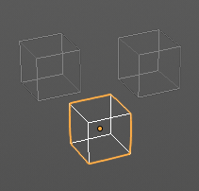
The selected object gets highlighted. The wire frame is white. The not selected objects shows a Grey wire frame.

Random
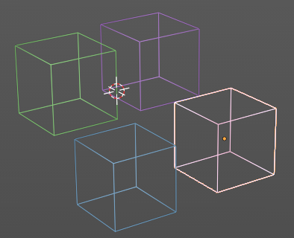
The selected object gets highlighted. The wire frame is a random wire frame color. The not selected objects shows a random wire frame color. You cannot influence this random color. It is random.

Background

Theme
Uses the viewport background color as defined in the theme.

World
Uses the world background color as the viewport background color.

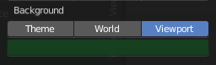
Viewport
Defines a custom color for the viewport background color.

Options

Show X Ray
This viewport setting is connected with the viewport shading. It allows you to show and edit the back geometry. Or hide it, so that you can just edit the geometry that points forwards.

X Ray Alpha
Adjust the amount of transparency.

Outline
Show the not selected objects with an outline.

Outline Color
Defines the color of the outline for not selected objects.

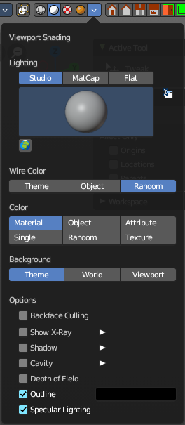
Viewport shading Settings with Solid

Lighting
Choose between different lighting methods.
Note that this methods are not for rendering the scene. This lighting methods are meant to light the viewport.

Studio
Uses a studio setup lighting. You can choose between several studio light setups in the library menu below. This library menu is a box with a preview of the currently active light setup.
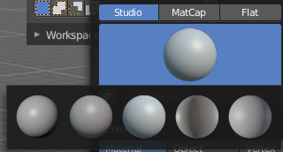

World Space Lighting
Make the lighting fixed to the world. And not follow the camera when you rotate around the scene.

Rotation
The rotation of the light setup. This edit box is just active when you use World Space Lighting.

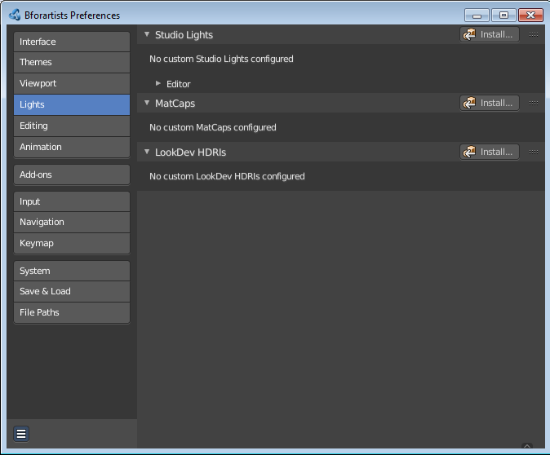
Show Light Preferences
At the right of the drop down box you will see a tiny button. It will open the preferences, where you can edit the existing studio light setups, or add new Studio light setups. This chapter is explained in the preferences manual part.

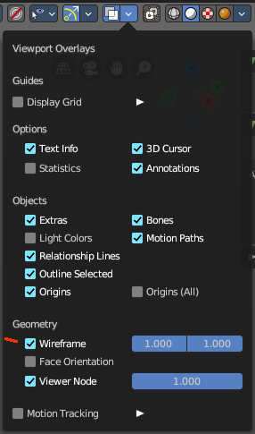
Wire Color
Allows you to display the wire color in different colors. Note that you need to have Wireframe display activated in the Viewport Overlays to see this effect.

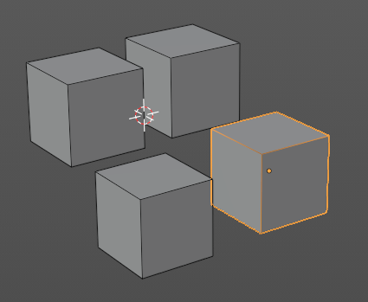
Theme
Displays the wireframe color as defined in the theme.

Object
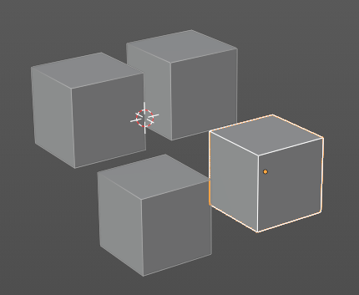
Displays the wireframe color object based.

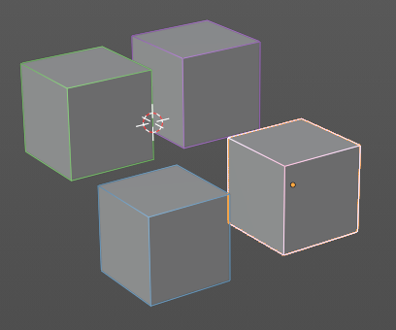
Random
Displays the wireframe color in a random color.

Color
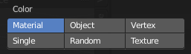
Influence how the objects in the scene are colored. Just one setting can be active at one time.

Material
Uses the color of the material, in case a material is assigned to the object(s).

Object
Uses the Object color.

Vertex
Shows the vertex colors in case vertex colors exists.

Single
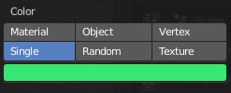
Define a custom color. A color picker box appears when you activate single.

Random
Colors the objects with a random color

Texture
Shows the texture in case a material with a texture is assigned to the object(s).

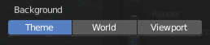
Background
Define the look of the viewport background

Theme
Uses the background as defined in the theme.

World
Uses the background as defined in the world settings of the scene.

Viewport
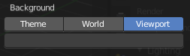
Use a custom color. When you activate this setting, then a color picker field appears, adjust a custom color.

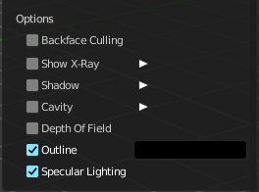
Options

Back face Culling
Use back face culling to hide backsides of faces.

Show X Ray
This viewport setting is connected with the viewport shading. It allows you to show and edit the back geometry. Or hide it, so that you can just see and edit the geometry that points forwards.
Note that you can either have Show X Ray active. Or Shadow and Cavity.

X Ray Alpha
Adjust the strength of the transparency effect.
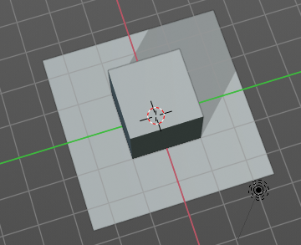

Shadow
Cast a shadow. Note that the shadow casting light is not part of the chosen studio light. It is an independent light.

Shadow Intensity
Here you adjust the strength of the shadow. Higher value means darker shadow.

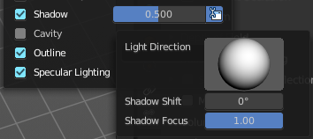
Light Settings
Adjust some settings of the light.

Light Direction
Click into the field and drag the mouse to change the direction of the light that casts the shadow.

Shadow Shift
The shadow termination angle. This can be used to minimize self shadowing artifacts.

Shadow Focus
The shadow hardness. It controls the falloff near the edge of the shadow.

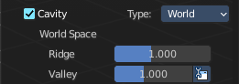
Cavity
Show Cavity. Cavity highlights ridges and valleys in the scene geometry. When you activate this setting, then further settings appears.

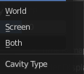
Type
The method how to calculate the cavity. In worlds pace, in screen space. Or in both.

World
Draw the cavity shading in world space.

World Space / Ridge Valley
Factor for the cavity ridges and valleys.

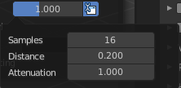
Shading Options
Adjust samples, distance and attenuation for the cavity ridges and valleys.

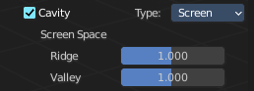
Screen
Draw the cavity shading in Screen space.

Screen Space / Ridge Valley
Factor for the curvature ridges and valleys.

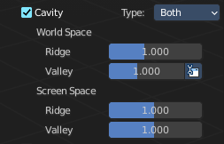
Both
Draw the cavity shading in both, World Space and Screen space.
Settings see above.

Depth of Field
Use depth of field for the viewport. It uses the values from the active camera.

Outline
Show the not selected objects with an outline.

Outline Color
Define the color of the outline for not selected objects.

Specular Lighting
Render specular highlights.

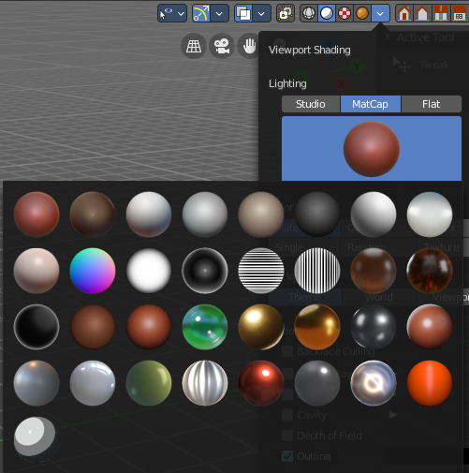
Matcap
Matcap stands for material capture. With Matcap you use a special matcap shader at the mesh. This shader is usually something colorful, which makes for example sculpting easier.
You can choose between several matcap setups in the library menu below. This library menu is a box with a preview of the currently active matcap setup.

Show Light Preferences
At the right of the library menu box you will see a tiny button. It will open the preferences, where you can edit the existing studio light setups, or add new Studio light setups. This chapter is explained in the preferences manual part.

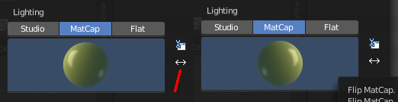
Flip Matcap
Some matcaps have a direction from which the light comes. With Flip Matcap you can flip this direction.

Color
Influence how the objects in the scene are colored. Just one setting can be active at one time.

Material
Uses the color of the material, in case a material is assigned to the object(s).

Object
Uses the Object color.

Vertex
Shows the vertex colors in case vertex colors exists.

Single
Define a custom color. A color picker box appears when you activate single.

Random
Colors the objects with a random color

Texture
Shows the texture in case a material with a texture is assigned to the object(s).

Background
This defines the look of the viewport background

Theme
Uses the background as defined in the theme.

World
Uses the background as defined in the world settings of the scene.

Viewport
Use a custom color. When you activate this setting, then a color picker field appears, adjust a custom color.

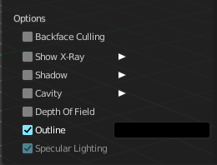
Options

Back face Culling
Use back face culling to hide backsides of faces.

Show X Ray
This viewport setting is connected with the viewport shading. It allows you to show and edit the back geometry. Or hide it, so that you can just see and edit the geometry that points forwards.

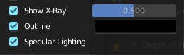
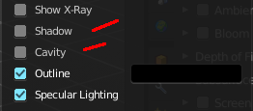
Note that you can either have Show X Ray active. Or Shadow and Cavity. When activating Show X Ray, the other two options will be hidden.

X Ray Alpha
Adjust the strength of the transparency effect.

Shadow
Cast a shadow. Note that the shadow casting light is not part of the chosen studio light. It is an independent light.

Shadow Intensity
Here you adjust the strength of the shadow. Higher value means darker shadow.

Light Settings
Adjust some settings of the light.

Light Direction
Click into the field and drag the mouse to change the direction of the light that casts the shadow.

Shadow Shift
The shadow termination angle. This can be used to minimize self shadowing artifacts.

Shadow Focus
The shadow hardness. It controls the falloff near the edge of the shadow.

Cavity
Show Cavity. Cavity highlights ridges and valleys in the scene geometry. When you activate this setting, then further settings appears.

Type
The method how to calculate the cavity. In worlds pace, in screen space. Or in both.

World
Draw the cavity shading in world space.

World Space / Ridge Valley
Factor for the cavity ridges and valleys.

Shading Options
Adjust samples, distance and attenuation for the cavity ridges and valleys.

Screen
Draw the cavity shading in Screen space.

Screen Space / Ridge Valley
Factor for the curvature ridges and valleys.

Both
Draw the cavity shading in both, World Space and Screen space.
Settings see above.

Outline
Show the not selected objects with an outline.

Outline Color
Define the color of the outline for not selected objects.

Specular Lighting
Render specular highlights.

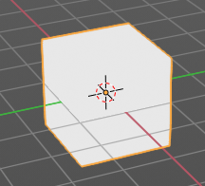
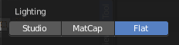
Flat
Lights the objects plain white.

Color
Influence how the objects in the scene are colored. Just one setting can be active at one time.

Material
Uses the color of the material, in case a material is assigned to the object(s).

Object
Uses the Object color.

Vertex
Shows the vertex colors in case vertex colors exists.

Single
Define a custom color. A color picker box appears when you activate single.

Random
Colors the objects with a random color

Texture
Shows the texture in case a material with a texture is assigned to the object(s).

Background
Define the look of the viewport background.

Theme
Uses the background as defined in the theme.

World
Uses the background as defined in the world settings of the scene.

Viewport
Use a custom color. When you activate this setting, then a color picker field appears, adjust a custom color.

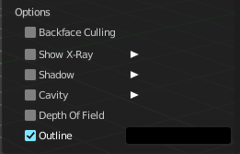
Options

Back face Culling
Use back face culling to hide backsides of faces.

Show X Ray
This viewport setting is connected with the viewport shading. It allows you to show and edit the back geometry. Or hide it, so that you can just see and edit the geometry that points forwards.
Note that you can either have Show X Ray active. Or Shadow and Cavity. When activating Show X Ray, the other two options will be hidden.

X Ray Alpha
Adjust the strength of the transparency effect.

Shadow
Cast a shadow. Note that the shadow casting light is not part of the chosen studio light. It is an independent light.

Shadow Intensity
Here you adjust the strength of the shadow. Higher value means darker shadow.

Light Settings
Adjust some settings of the light.

Light Direction
Click into the field and drag the mouse to change the direction of the light that casts the shadow.

Shadow Shift
The shadow termination angle. This can be used to minimize self shadowing artifacts.

Shadow Focus
The shadow hardness. It controls the falloff near the edge of the shadow.

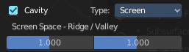
Cavity
Show Cavity. Cavity highlights ridges and valleys in the scene geometry. When you activate this setting, then further settings appears.

Type
The method how to calculate the cavity. In worlds pace, in screen space. Or in both.

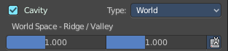
World
Draw the cavity shading in world space.

World Space / Ridge Valley
Factor for the cavity ridges and valleys.

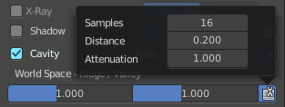
Shading Options
Adjust samples, distance and attenuation for the cavity ridges and valleys.

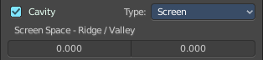
Screen
Draw the cavity shading in Screen space.

Screen Space / Ridge Valley
Factor for the curvature ridges and valleys.

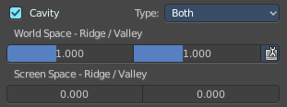
Both
Draw the cavity shading in both, World Space and Screen space.
Settings see above.

Outline
Show the not selected objects with an outline.

Outline Color
This defines the color of the outline for not selected objects.

Specular Lighting
Render specular highlights.

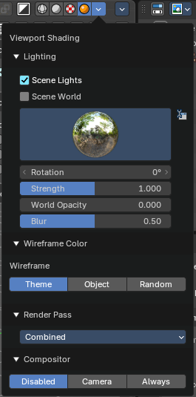
Viewport Shading with Material Preview
In this mode you can use a hdr file to light the scene.
This mode is just available with Cycles and Eevee renderer. Workspace renderer does not have this mode.

Lighting

Scene Lights
Use the scene lights instead of the hdr to light the scene.

Scene World
Use the scene world to light the scene. This turns off the hdr. And the further options are not longer available.

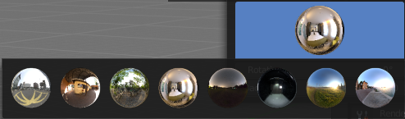
HDR File Browser
Pick a hdr file to light the world with.

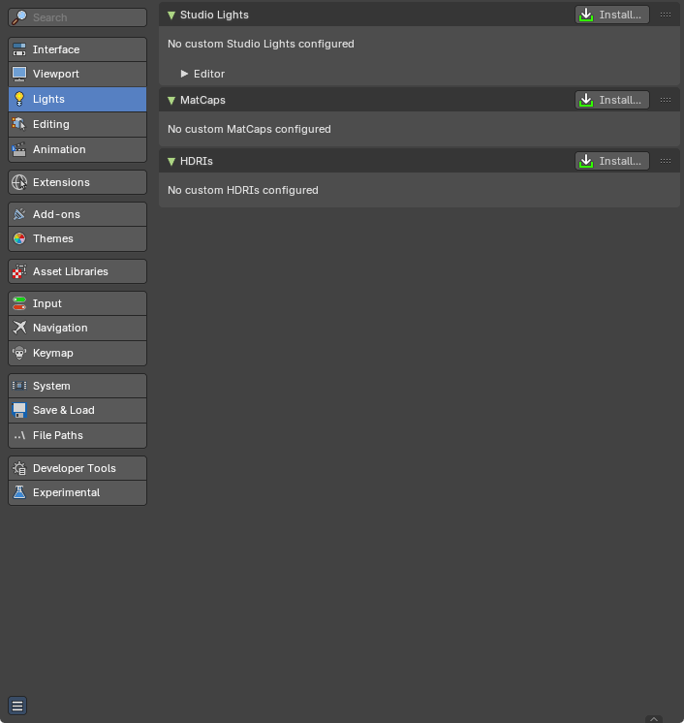
Show light preferences
At the right of the library menu box you will see a tiny button. It will open the preferences, where you can edit the existing studio light setups, or add new Studio light setups. This chapter is explained in the preferences manual part.

World Space Lighting
Make the hdr rotation fixed, and not follow the camera.

Rotation
The rotation of the hdr file.

Background
Show the studio light in the background. The higher the value the more the studio light gets mixed into the hdr.

World Opacity
Show the studio light in the background

Blur
The blur factor.

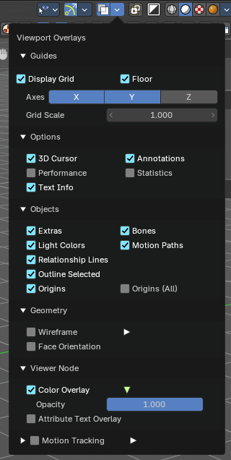
Wire Color
Allows you to display the wire color in different colors. Note that you need to have Wireframe display activated in the Viewport Overlays to see this effect.

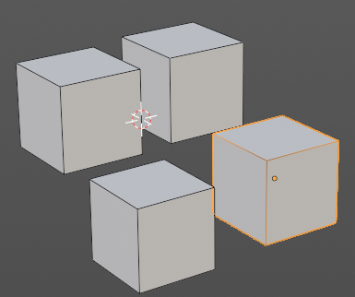
Theme
Displays the wireframe color as defined in the theme.

Object
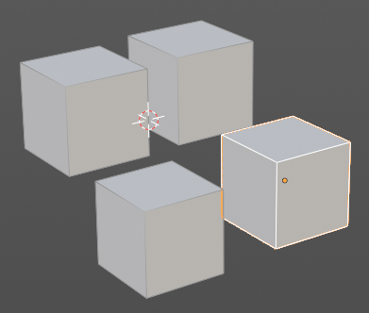
Displays the wireframe color object based.

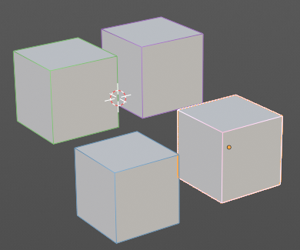
Random
Displays the wireframe color in a random color.

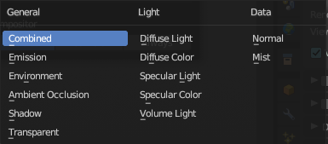
Render Pass
Choose what render passes to calculate.

Compositor
Alllows you to display the compositor result in the viewport. Note that you need to have a active compositor node setup for this to work.

Disabled
To display the compositor result in the viewport is disabled.

Camera
Displays the compositor result when you are in camera view.

Always
Always displays the compositor result.

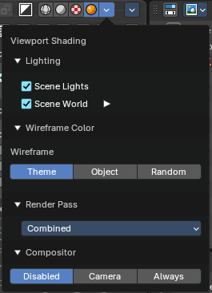
Viewport Shading with Rendered
With rendered shading the viewport uses the renderer settings of the chosen render engine. Workbench has no specific shading settings here. And the panel is empty. Cycles and Eeevee have some further settings.

Lighting

Scene Lights
Render lights and light probes in the scene.

Scene World
Use scene world for lighting. When you turn off Scene World then you reveal further settings.

Studiolight Preview
Displays the current active hdri file to light the scene. A click at the display allows you to pick another hdri file.
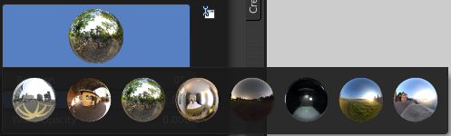

Show Light preferences
Opens the light preferences in the preferences where you can pick more hdri files.

Rotation
The rotation of the studio light.

Strength
The strength of the studio light.

World Opacity
The opacity of the hdri.

Blur
Eevee. Blur the studiolight in the background.

Wire Color
Allows you to display the wire color in different colors. Note that you need to have Wireframe display activated in the Viewport Overlays to see this effect.

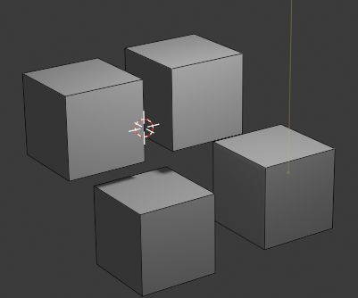
Theme
Displays the wireframe color as defined in the theme.

Object
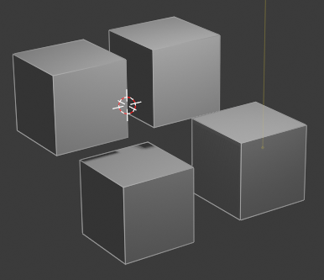
Displays the wireframe color object based.

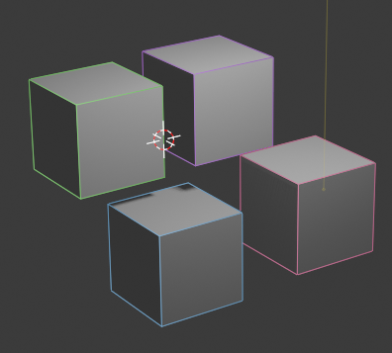
Random
Displays the wireframe color in a random color.

Render Pass
Choose what render passes to calculate.

Compositor
Alllows you to display the compositor result in the viewport. Note that you need to have a active compositor node setup for this to work.

Disabled
To display the compositor result in the viewport is disabled.

Camera
Displays the compositor result when you are in camera view.

Always
Always displays the compositor result.

Pause Preview
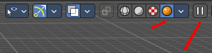
When you choose the Cycles renderer and set the viewport shading mode to rendered, then it reveals one more button at the right. Pause Preview pauses the rendering in the viewport when Cycles is chosen as the viewport renderer.

Align View Buttons
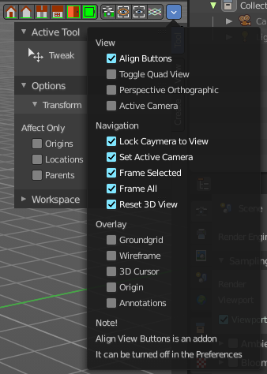
Align View Buttons is an addon. The buttons allows you to align the view to the orthographic views. And brings further functionality from the View menu and other hard to reach locations.
The content is all a double entry by purpose, to have these buttons at the top hierarchical position for quick access. And it is already described at the original UI position. So we won't go into detail here.
This addon can be turned off in the Preferences.

Grease Pencil - all modes - Layer Panel

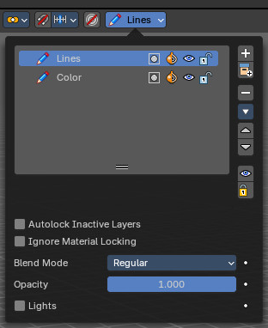
This panel shows in most of the modes. It is the same content than the Layers panel in the Object Data Properties.

Layer list

Layer name
The name of the layer.

Mask Layer
Toggle the Masks visibility in the layer.

Onion Skinning
Toggle the use the layer for Onion Skinning.

Viewport/Render Visibility
Toggle layer visibility in the viewport and in render.

Lock
Toggle layer from being editable.

Search Field
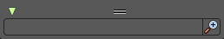
You can expand a search field at the bottom of the list. Type in your term and hit enter to filter for your term.

Add new layer
Adds a new layer.

Remove layer
Removes the selected layer.

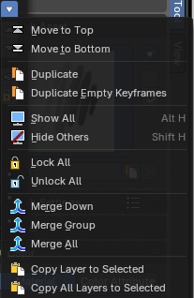
Layer Specials

Move to Top
Moves the selected layer to the top of the list.

Move to Bottom
Moves the selected layer to the bottom of the list.

Duplicate Layer
Makes an exact copy of the selected layer appending a number to differentiate its name.

Duplicate Empty Keyframes
Makes a copy of the active grease pencil layer.

Show All
Turns on the visibility of every layer in the list.

Hide Others
Turns off the visibility of every layer in the list except the active one.

Lock All
Locks edition of all the layers in the list

Unlock All
Unlocks edition of all the layers in the list.

Merge Down
Merge the selected layer with the layer below, the new layer keeps the name of the lower layer.

Merge Group
Merge the selected layer in the active group with the layer below, the new layer keeps the name of the lower layer.

Merge All
Merge the selected layer with all other layers.

Copy Layer to Selected
Makes a copy of the layer and move it to the selected Grease Pencil object.

Copy all Layers to Selected
Makes a copy of all layers and moves it to the selected Grease Pencil object.

Reorder Layer up/down
Moves the selected layer up or down in the list.

Isolate Layers
Hide and lock the layer.

Isolate Layers
Lock the layer.

Autolock inactive layer
Locks automatically the edition of every layer in the list except the active one. This way you avoid to make unwanted changes in other layers without the need to lock them every time.

Igonre Material Locking
Allow editing strokes even if they use locked materials.

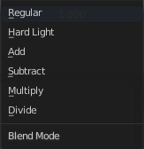
Blend mode
The layer blending operation to perform. See Color Blend Modes.

Opacity
Used to set the opacity of the layer.

Lights
When enabled, the layer is affected by lights.

Grease Pencil - Options Panel

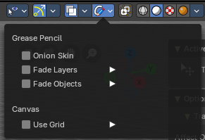
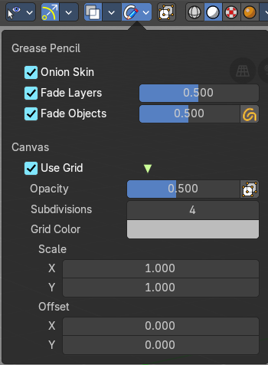
Options for the use of the grease pencil.

Grease Pencil - all modes

Onion Skin
Use onion skinning. Onion skinning shows ghosts of the keyframes before and after the current position.

Fade Layers
Fade all layers except the active one.

Opacity
The fading opacity.

Fade Objects
Fade all objects except the active one.

Opacity
The fading opacity.

Fade Grease Pencil Objects
Fade also all Grease Pencil Objects except the active one.

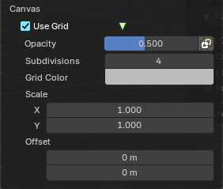
Canvas

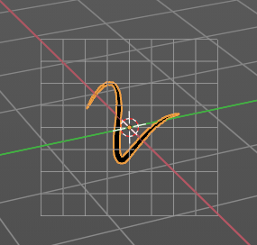
Use Grid
Use a reference grid behind the grease pencil.

Opacity
The opacity of the grid.

Canvas X Ray
Show the canvas in front of the grease pencil.

Subdivisions
How much subdivisions the grid has.

Grid Color
The grid color.

Scale X , Y
The size of the grid.

Offset
The offset of the grid.

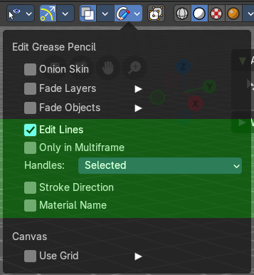
Grease Pencil - Edit mode
In Edit mode a few more options appears

Edit Lines
Show editing lines when editing strokes.

Only in Multiframe
Show edit lines only in multiframe.

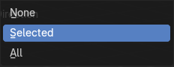
Handles
Limit the display of curve handles in edit mode.

None
Handles are not displayed.

Selected
Just the handles of the selection are displayed.

All
All handles are displayed.

Stroke Direction
Show stroke drawing direction. The direction is indicated by a green dot.

Material Name
Show the material name that is assigned to each stroke.

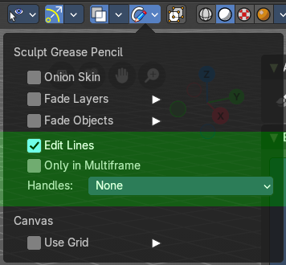
Grease Pencil - Sculpt mode

Edit Lines
Show editing lines when editing strokes.

Only in Multiframe
Show edit lines only in multiframe.

Handles
Limit the display of curve handles in edit mode.

None
Handles are not displayed.

Selected
Just the handles of the selection are displayed.

All
All handles are displayed.

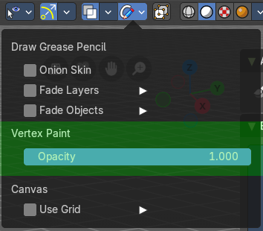
Grease Pencil - Draw mode

Vertex Paint

Opacity
The vertex paint mix factor.

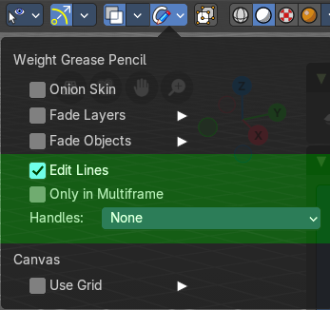
Grease Pencil - Weight Paint mode

Edit Lines
Show editing lines when editing strokes.

Only in Multiframe
Show edit lines only in multiframe.

Handles
Limit the display of curve handles in edit mode.

None
Handles are not displayed.

Selected
Just the handles of the selection are displayed.

All
All handles are displayed.

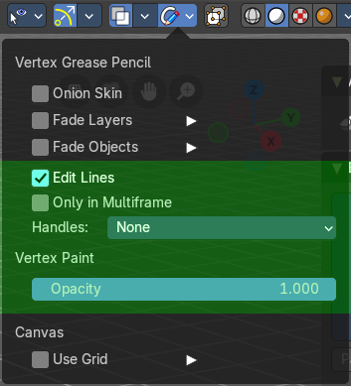
Grease Pencil - Vertex Paint mode

Edit Lines
Show editing lines when editing strokes.

Only in Multiframe
Show edit lines only in multiframe.

Handles
Limit the display of curve handles in edit mode.

None
Handles are not displayed.

Selected
Just the handles of the selection are displayed.

All
All handles are displayed.

Vertex Paint

Opacity
The vertex paint mix factor.

Grease Pencil - Sculpt mode - Auto-masking Panel

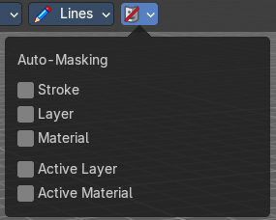
Automasking settings.

Stroke
Affect only strokes below the cursor that are the same stroke.

Layer
Affect only strokes below the cursor that are at the same layer.

Material
Affect only strokes below the cursor that have the same material.

Active Layer
Affect only the active layer.

Active material
Affect only strokes with the active material.

